

**About me :-** Hi, I’m Shantanu Rana. Currently I’m in my third year. But I want to make things easy to all of you. I have watched Kunal Kushwaha’s video on git and github. After watching his video I decided to compile the things and prepared a tutorial pdf by myself.

One can watch his video and and then refer to this pdf.

**Video link :-**

https://www.youtube.com/watch?v=apGV9Kg7ics&list=PL9gnSGHSqcnr_DxHsP7AW9ftq0AtAyYqJ&index=5

**Before starting the git and github first download git in your PC’s :-**

**For downloading git follow this :-**

[**https://git-scm.com/downloads**](https://git-scm.com/downloads)

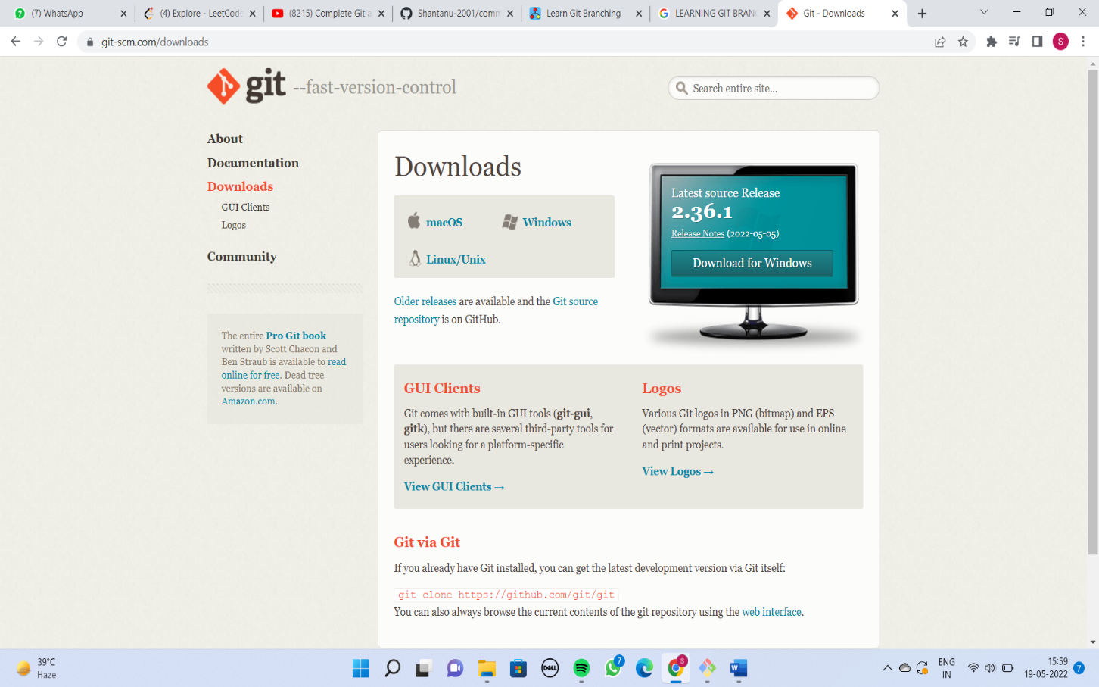

After downloading git make your account on Github which is very important.

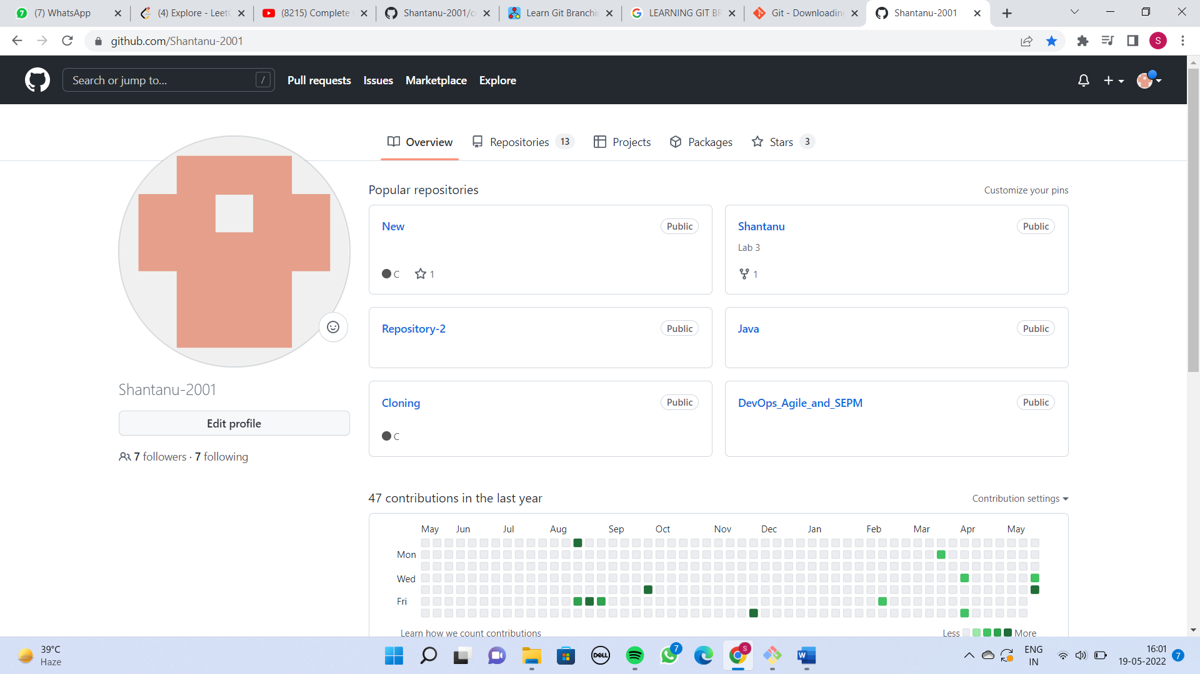

**Running git commands**

Now open your git terminal and then we’ll see git commands.

1. **git init** :- git init is one way to start a new project with Git. To start a repository, use either git init. To initialize a repository, Git creates a hidden directory called . git . That directory stores all of the objects and refs that Git uses and creates as a part of your project's history.

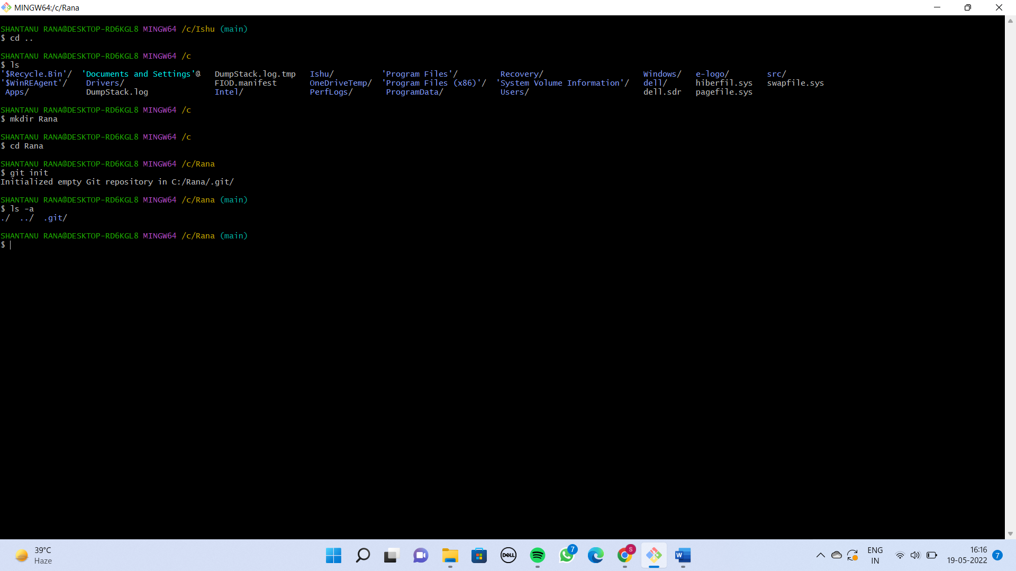

1. **git add .** :- The git add command adds new or changed files in your working directory to the Git staging area.git add is an important command - without it, no git commit would ever do anything. Sometimes, git add can have a reputation for being an unnecessary step in development. But in reality, git add is an important and powerful tool. git add allows you to shape history without changing how you work.

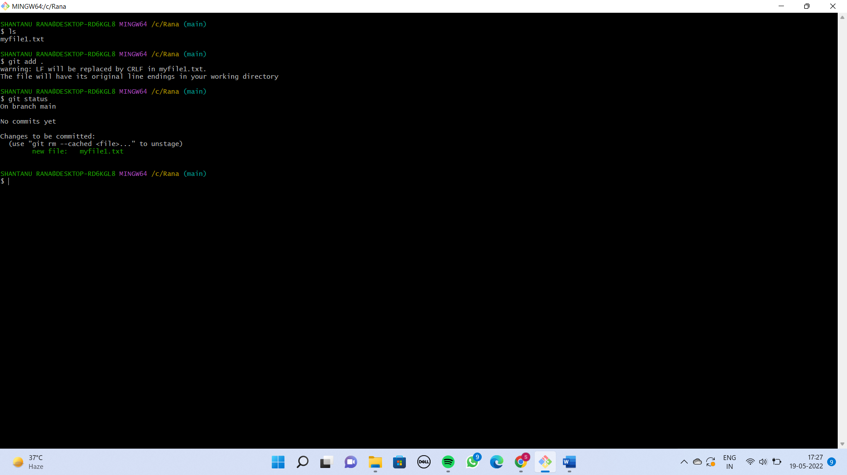

After that we can see the added file by using git status command.

1. **git status :-** The git status command displays the state of the working directory and the staging area. It lets you see which changes have been staged, which haven't, and which files aren't being tracked by Git. Status output does not show you any

information regarding the committed project history.

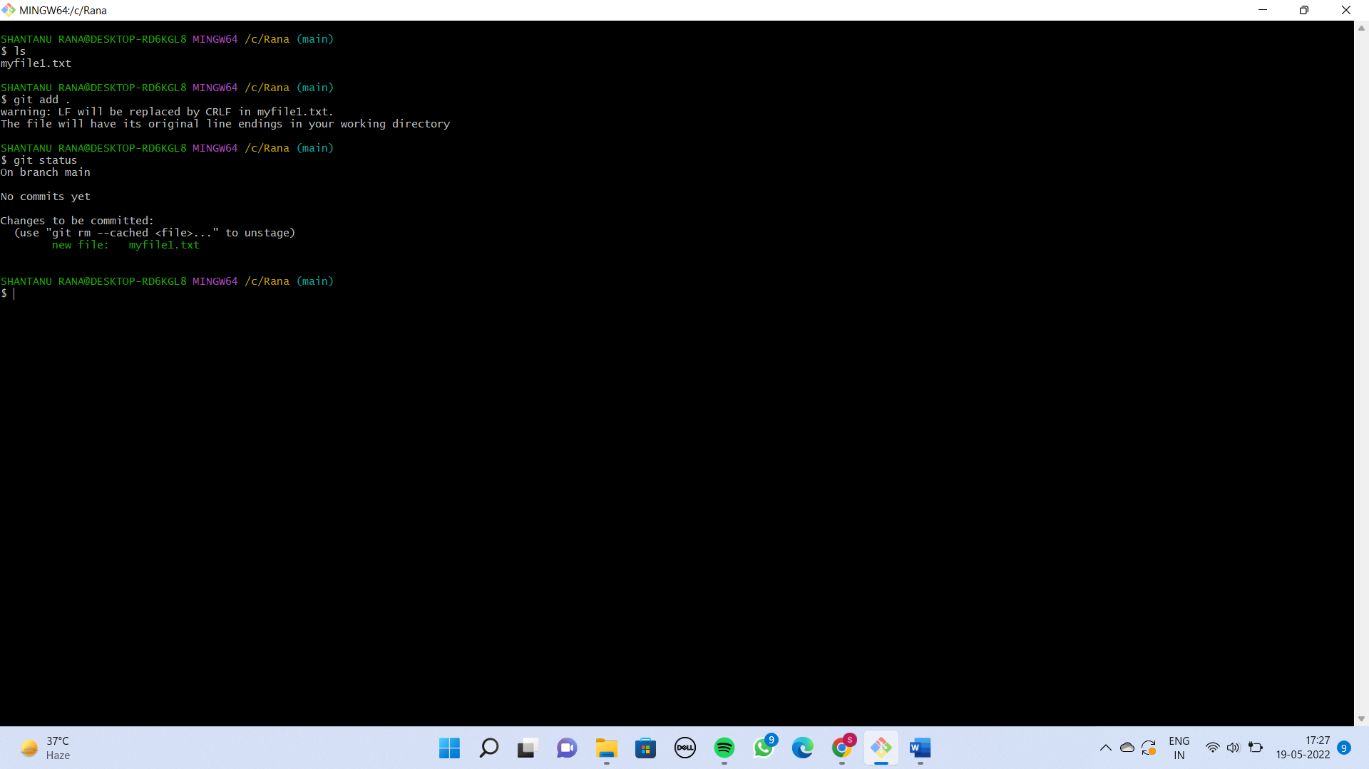

1. **git commit** :- The "commit" command is used to save your changes to the local repository. Suppose I have made a file called myfile.txt and I want to commit so here I use the syntax like this :-

git commit -m “Added new file”

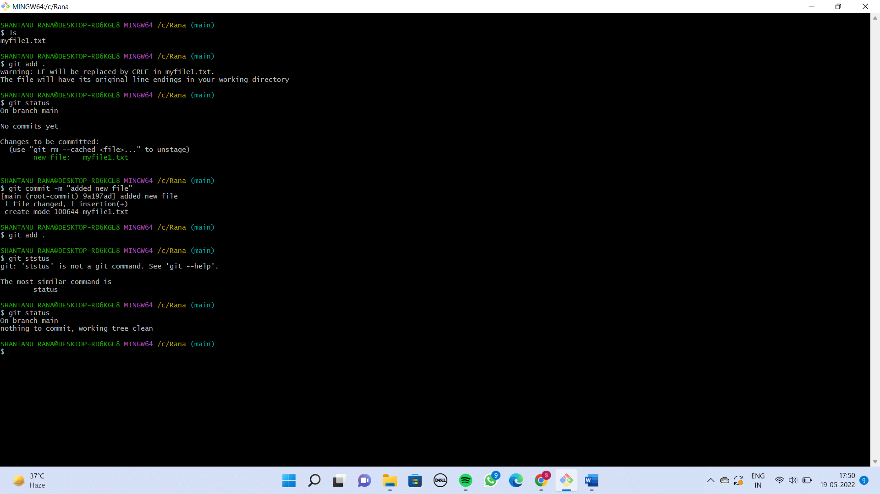

Now If I want to check the history of all the commits so we have command git log for it.

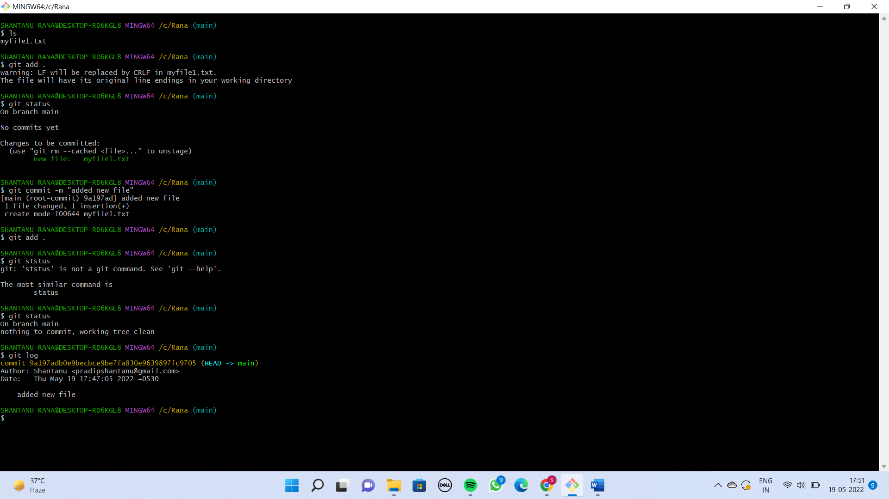

1. **rm -rf file.txt** :- It is used to delete the file.

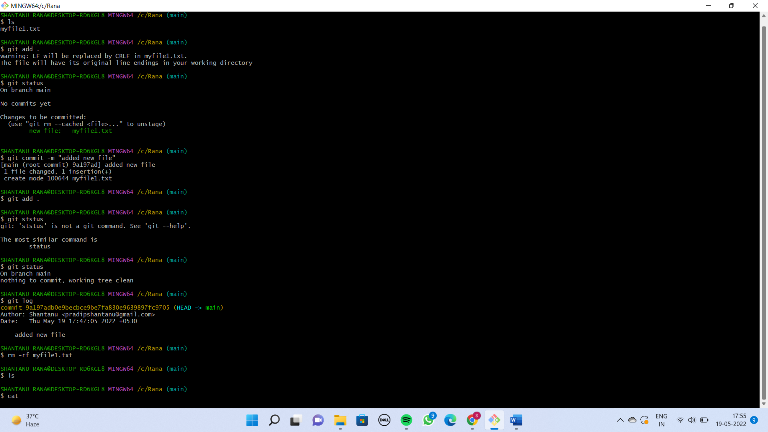

1. **git reset** :- To delete the commits. Suppose I have commited 3 times.

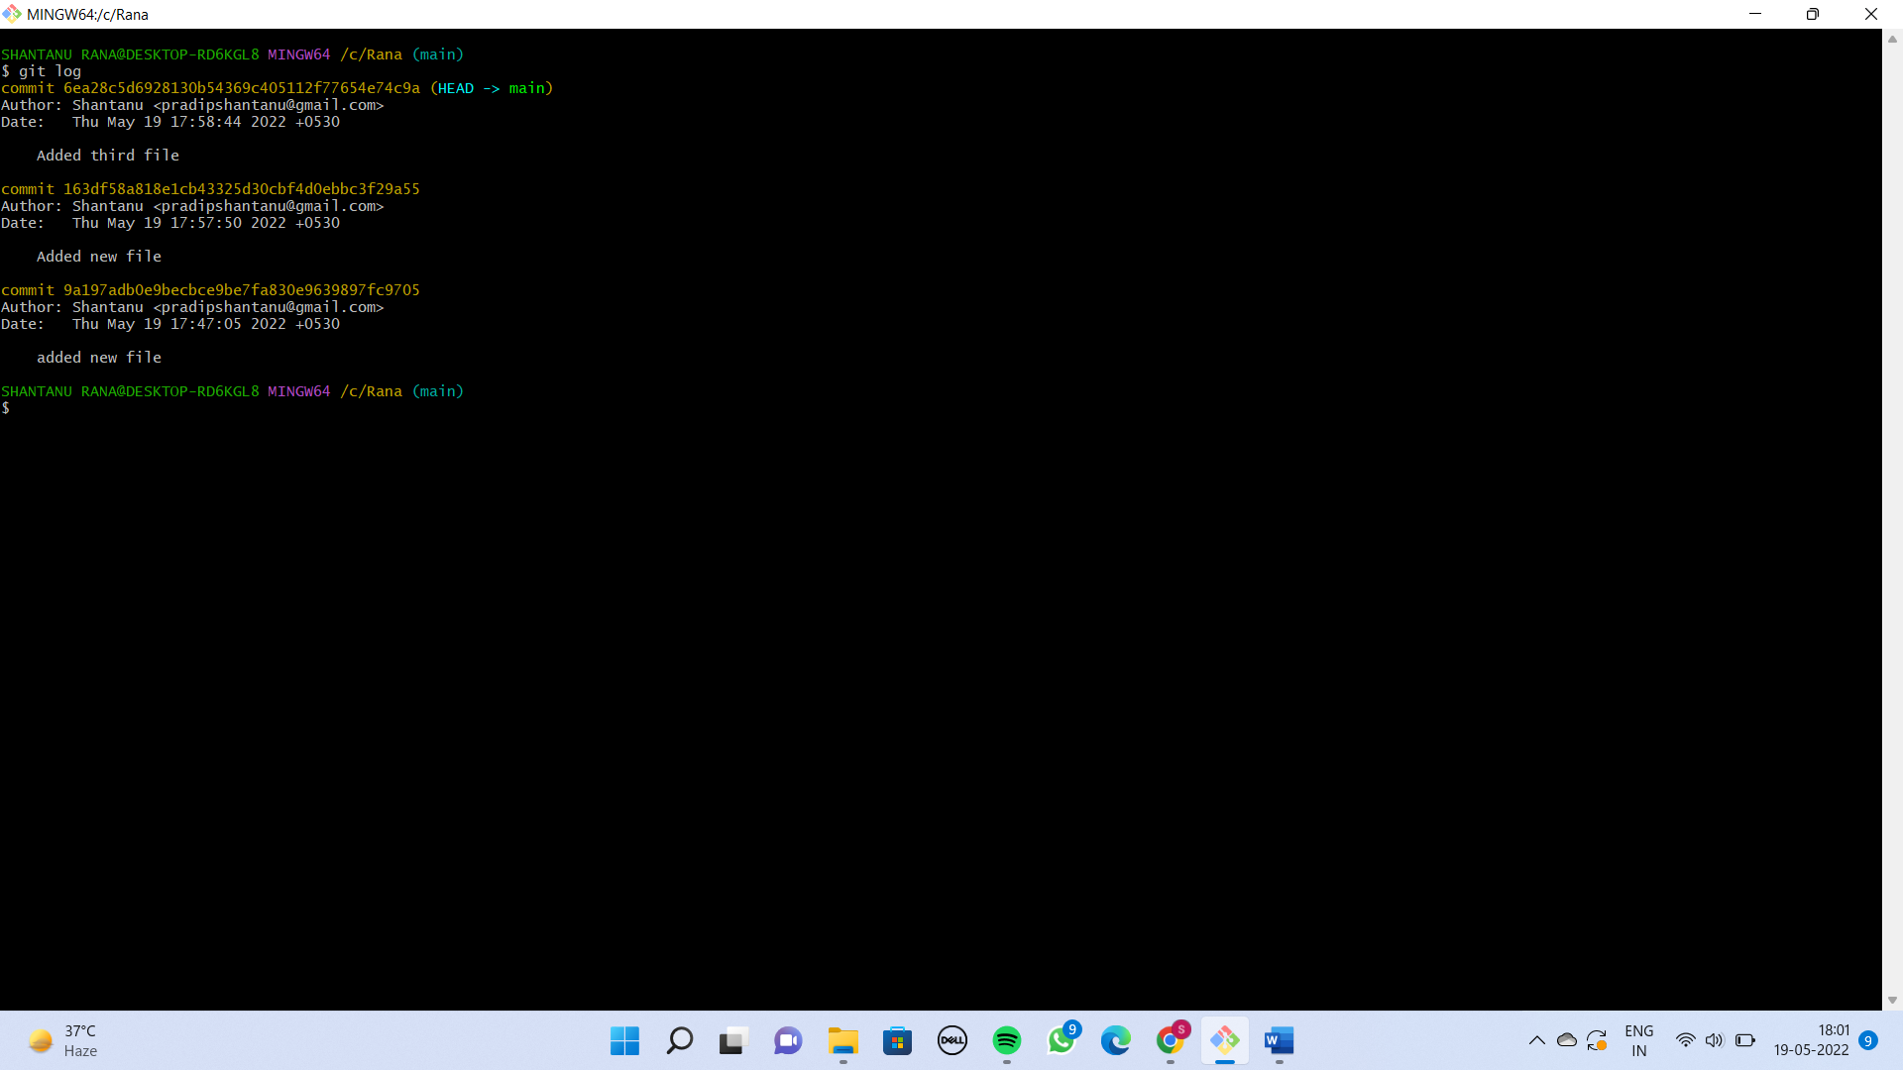

So here I want to delete the last two commits. So for doing that I’ll copy the commit Id of first commit and paste it in the git reset command.

git reset 9a197adb0e9becbce9be7fa830e9639897fc9705

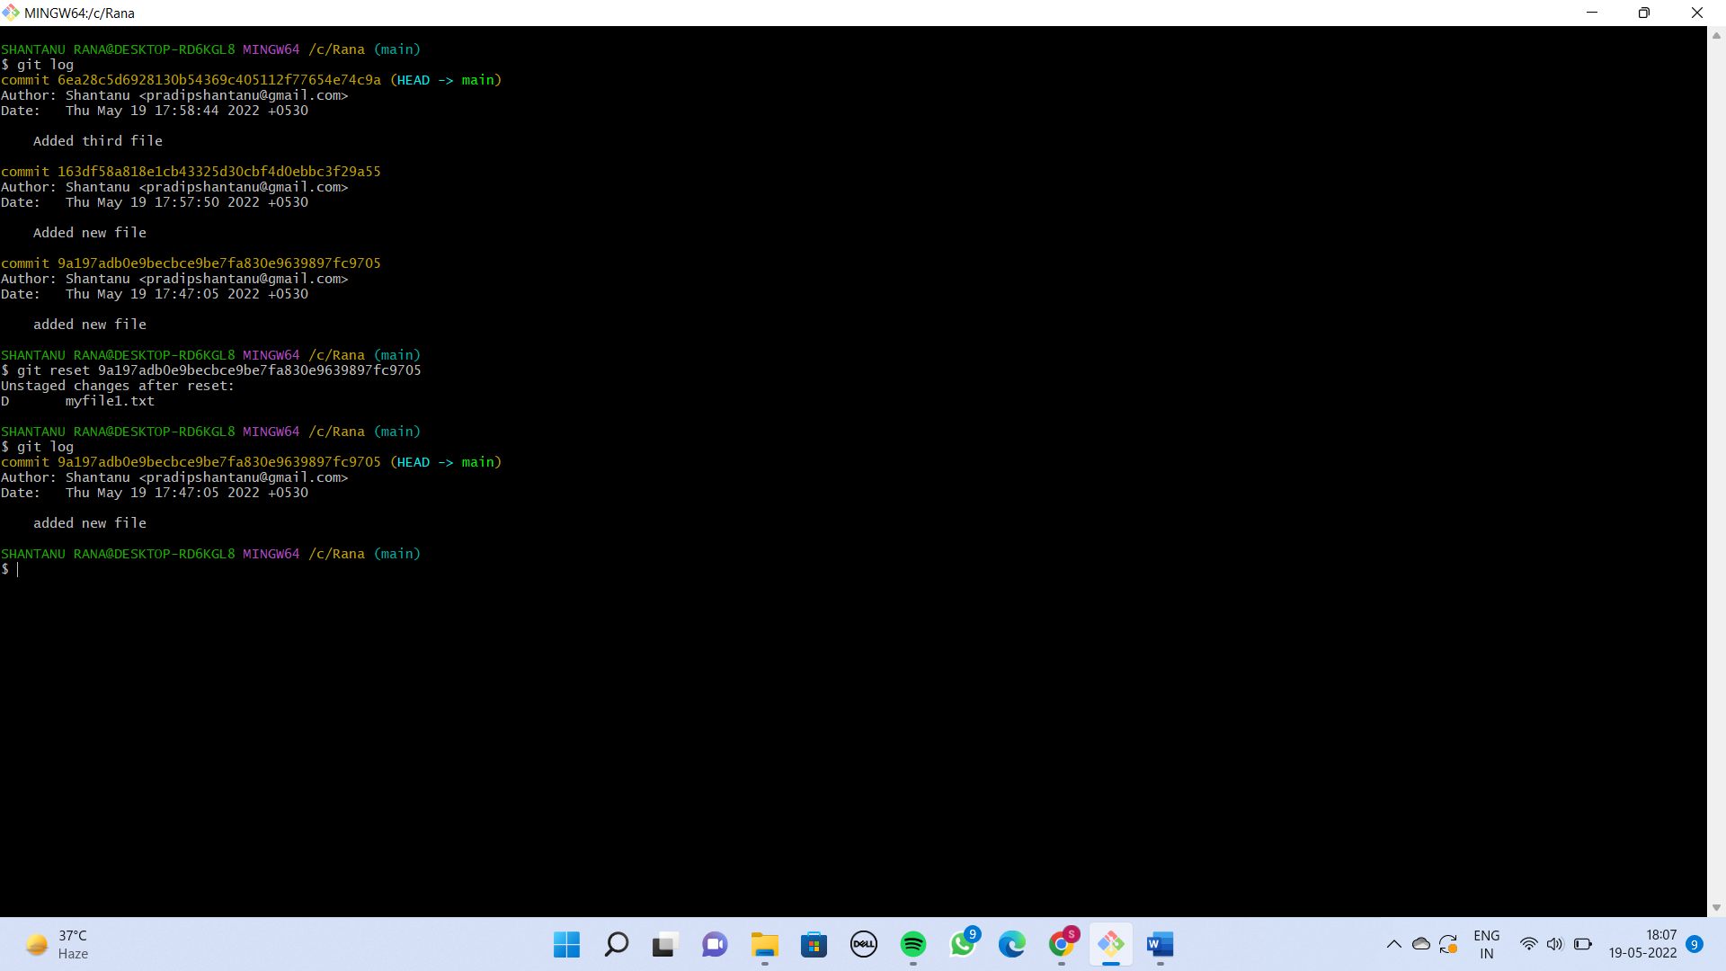

by doing this the last 2 commits are deleted now.

**PUSHING OUR WORK FROM TO LOCAL REPOSITORY TO GITHUB**

**Step 1** :- Create a repository on github. Suppose I created a repository name Tutorial.

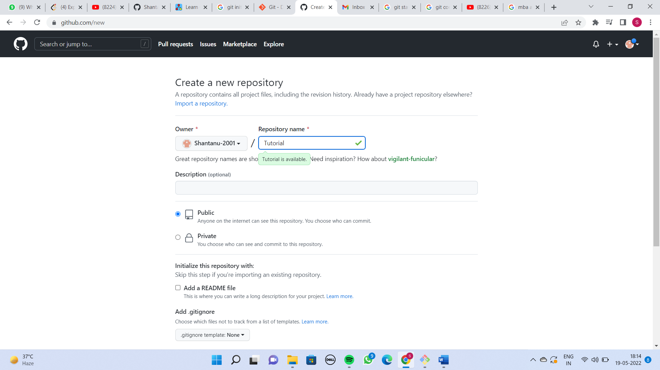

**Step 2** :- After creating the Repository now copy the URL of the repository and paste in this command :-

**git remote add origin** [**https://github.com/Shantanu-2001/Tutorial**](https://github.com/Shantanu-2001/Tutorial)

**remote :- It represents you are working with URL.**

**add :- You are adding a new URL.**

**Origin :- What is the name of the URL that you are going to add.**

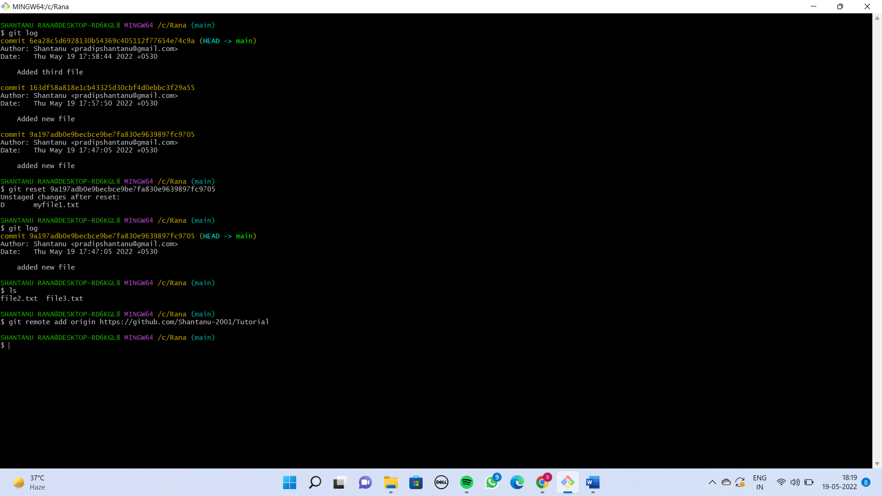

Step 3 :- Now type this command to push the work on Github.

**git push origin main**

**:- here main is the branch in which you are working on.**

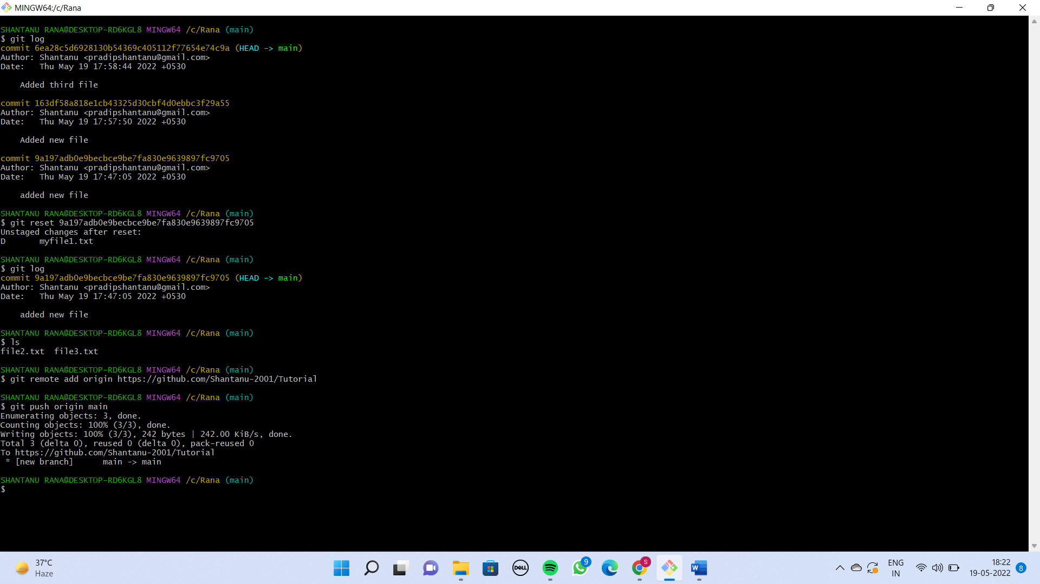

**Finally the all the files are pushed in our github repository.**

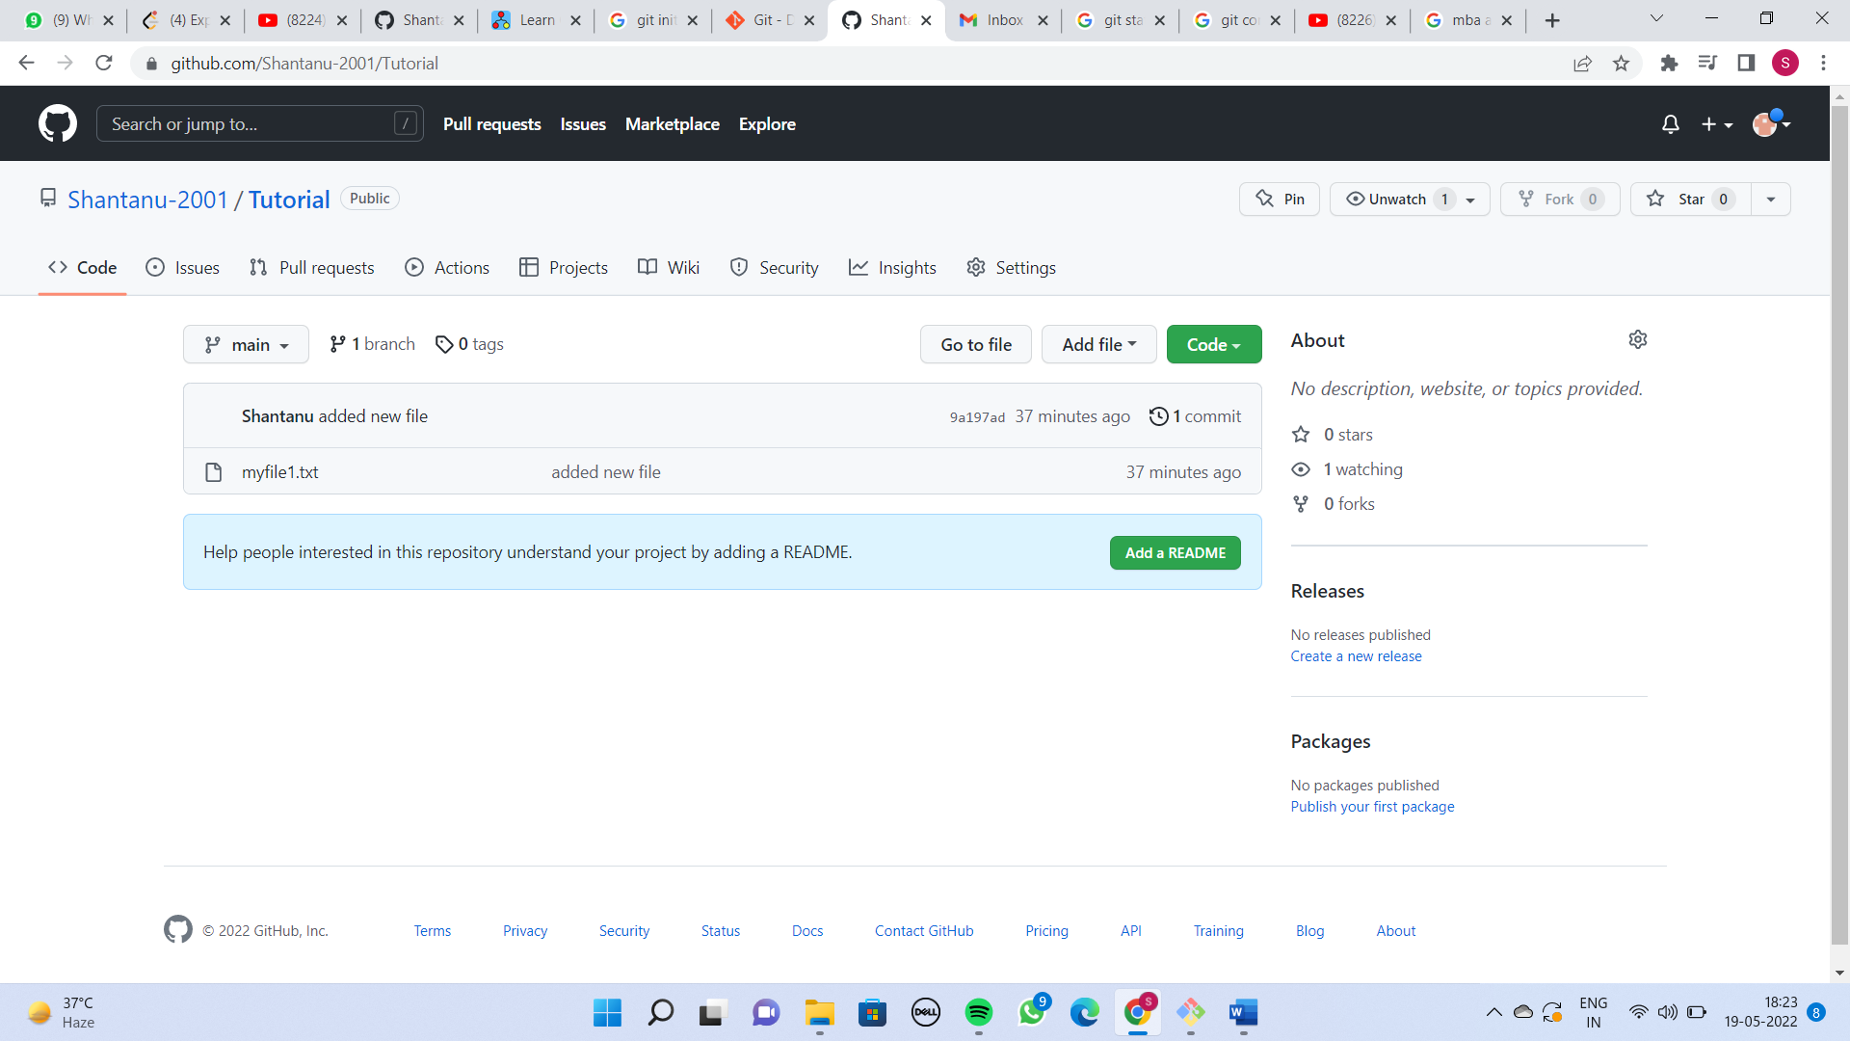

**WHAT IS THE USE OF BRANCH ?**

Let’s visualize I have created 4 commit.

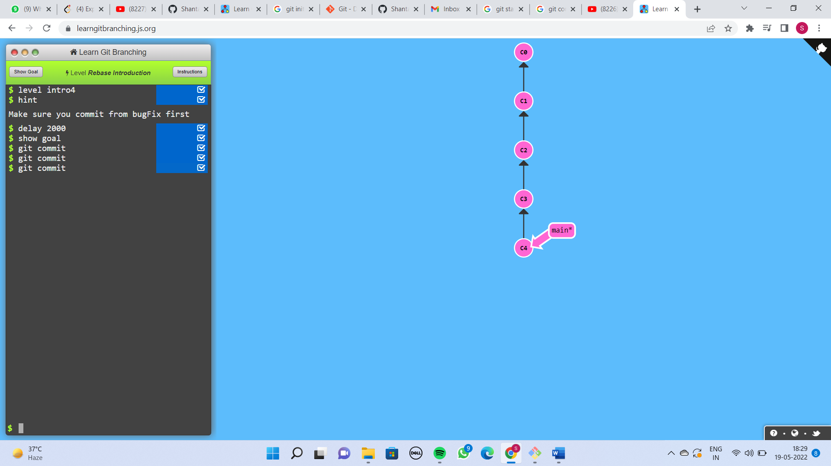

We can see this thing is being formed in sort of branch structure. This is called Acyclic graph.

By default the branch name is main. Previously it’s name was Master.

**The use of Branch :-**

Whenever we are working on other features or resolving a bug or whatever.

Always create a separate branch. In branches what happens is that you should never commit on main branch because in open source project our code which is not finalized yet might contains some errors that is why all the code which is not finalized that you are working on should go on separate branch where the users are not affected for that we can create new branch.

For that we can create new branch by using commands:-

**git branch feature**

**git checkout feature**

here feature is the name of our branch. You can name it anything.

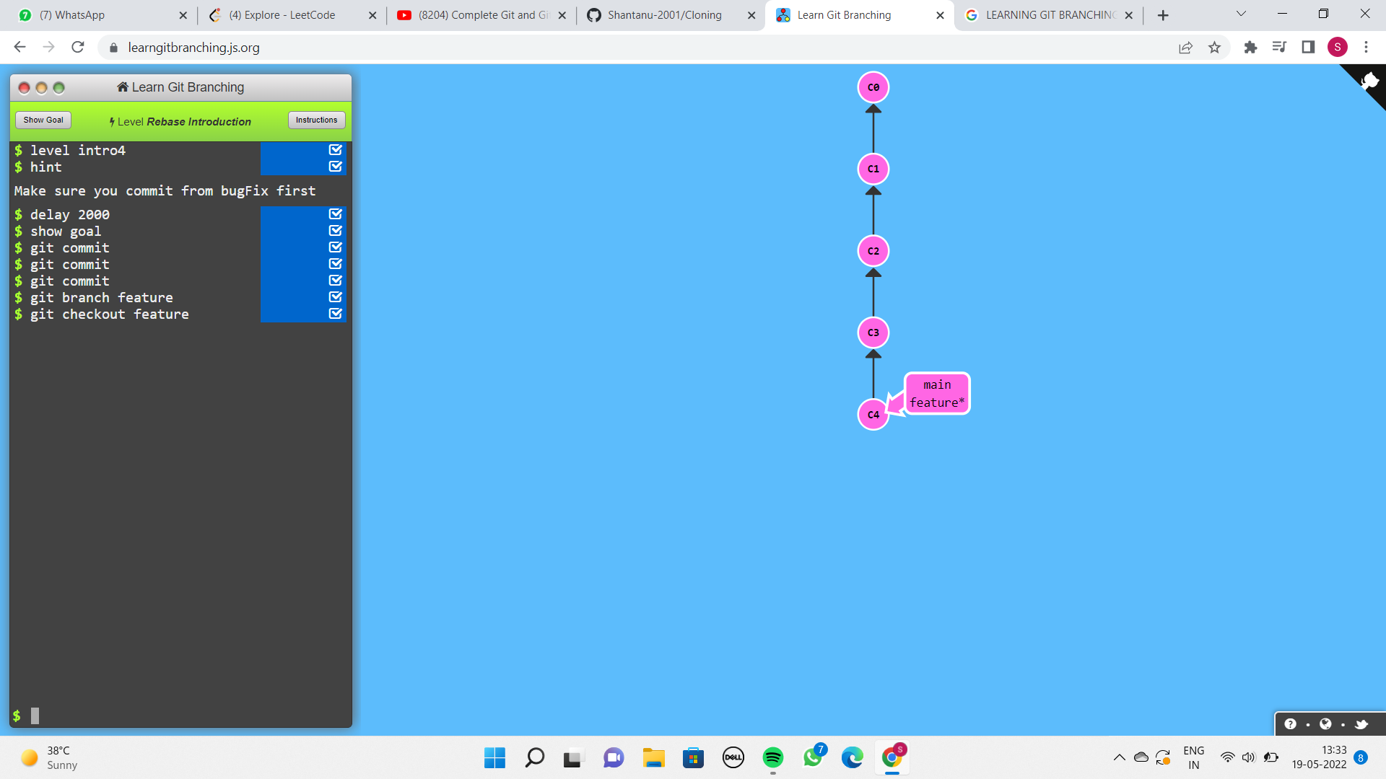

When we did git checkout feature then the * is on feature.

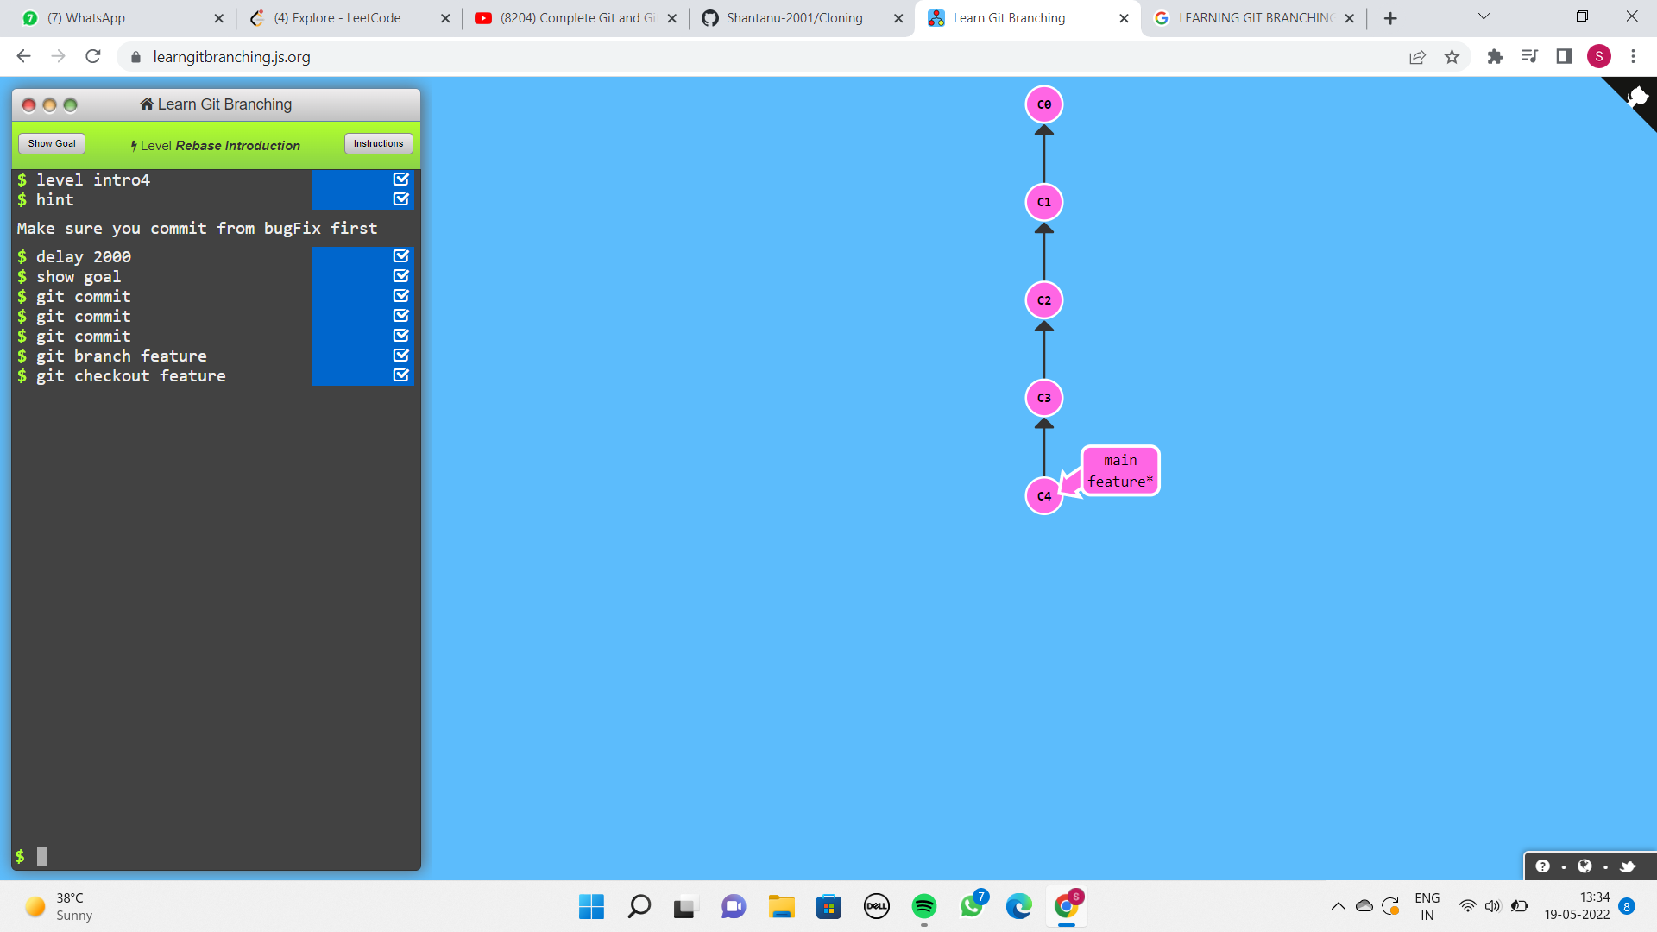

This basically means the head is now pointing on feature branch.

**Head :- head is just a pointer which says all the new commits that you’ll make will be added on the head.**

Currently head is on feature branch hence all the new commits I’m making will be added on the feature branch.

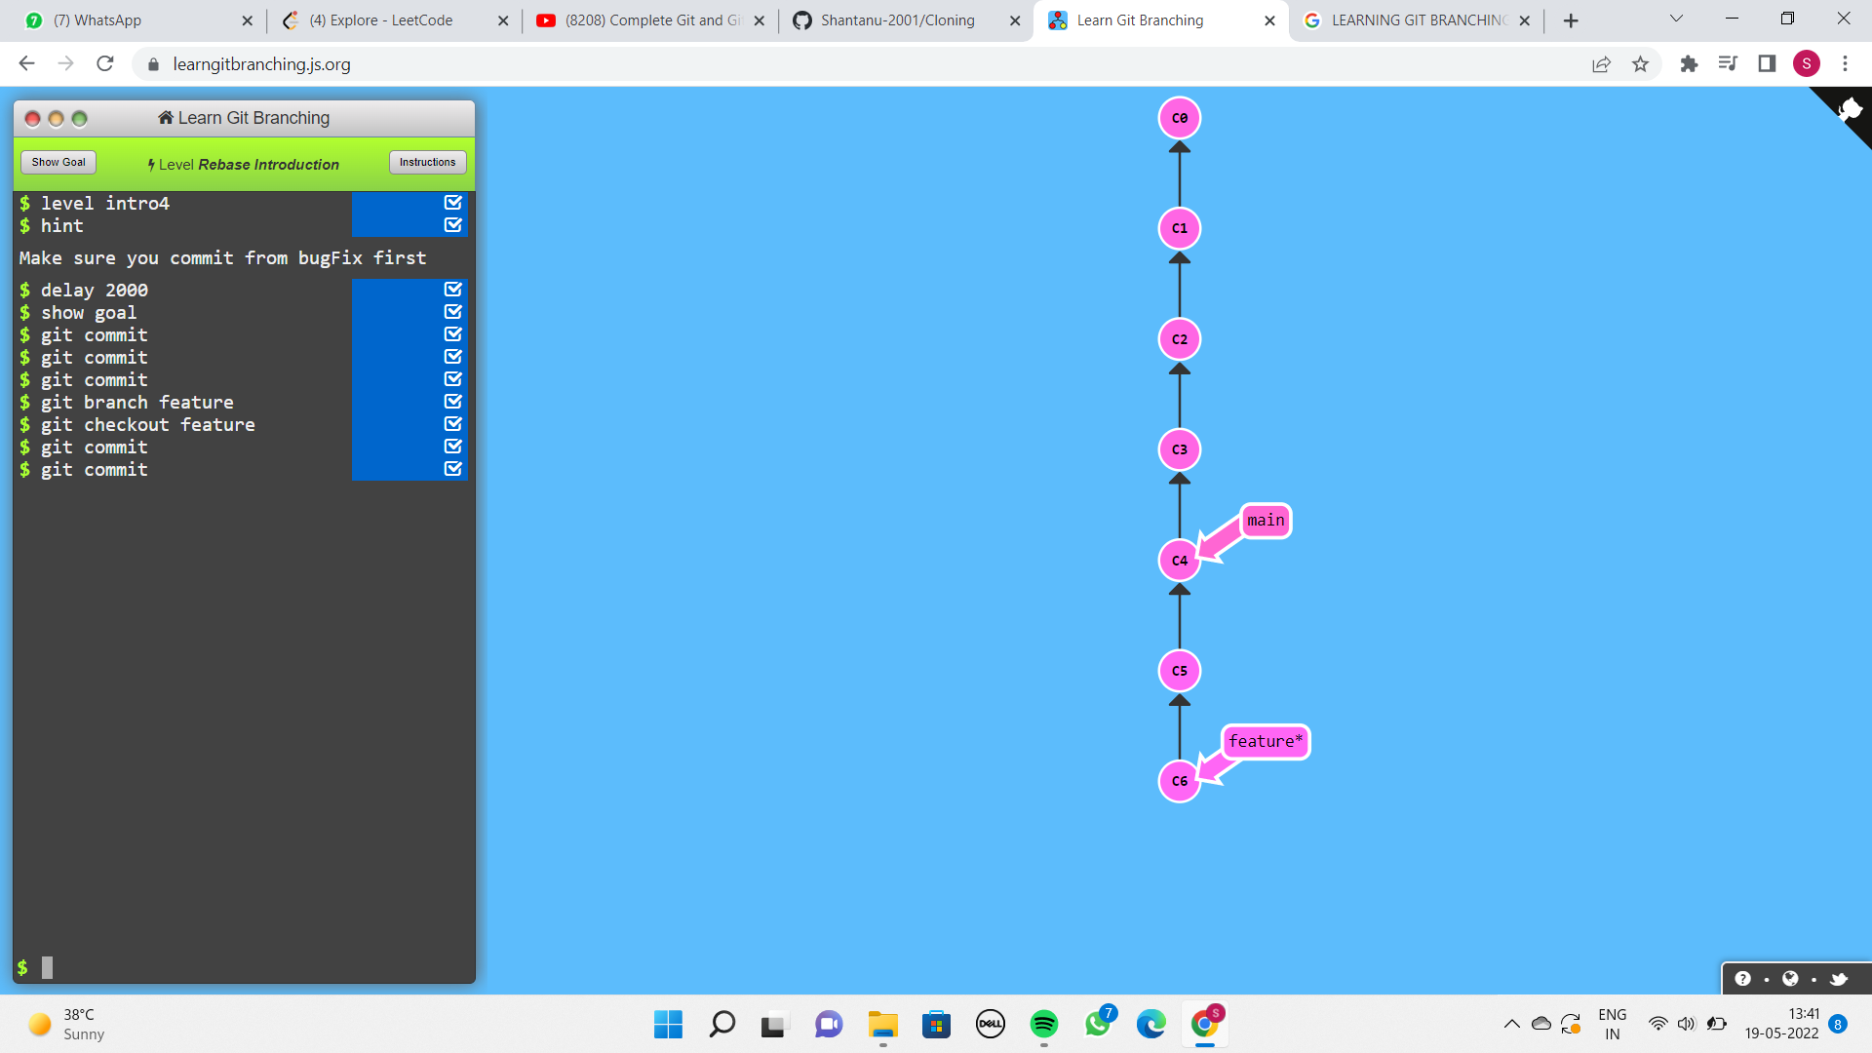

Only the feature branch is moving forward the main branch is as it is.

Another thing is we are not the only one who are going to be contributing to the codebase so many people can contribute.

So let’s say while you are working on the project on your separate branch. While you are working on your issues. Someone else get’s their code added in the main branch.

**git checkout main**

**git commit**

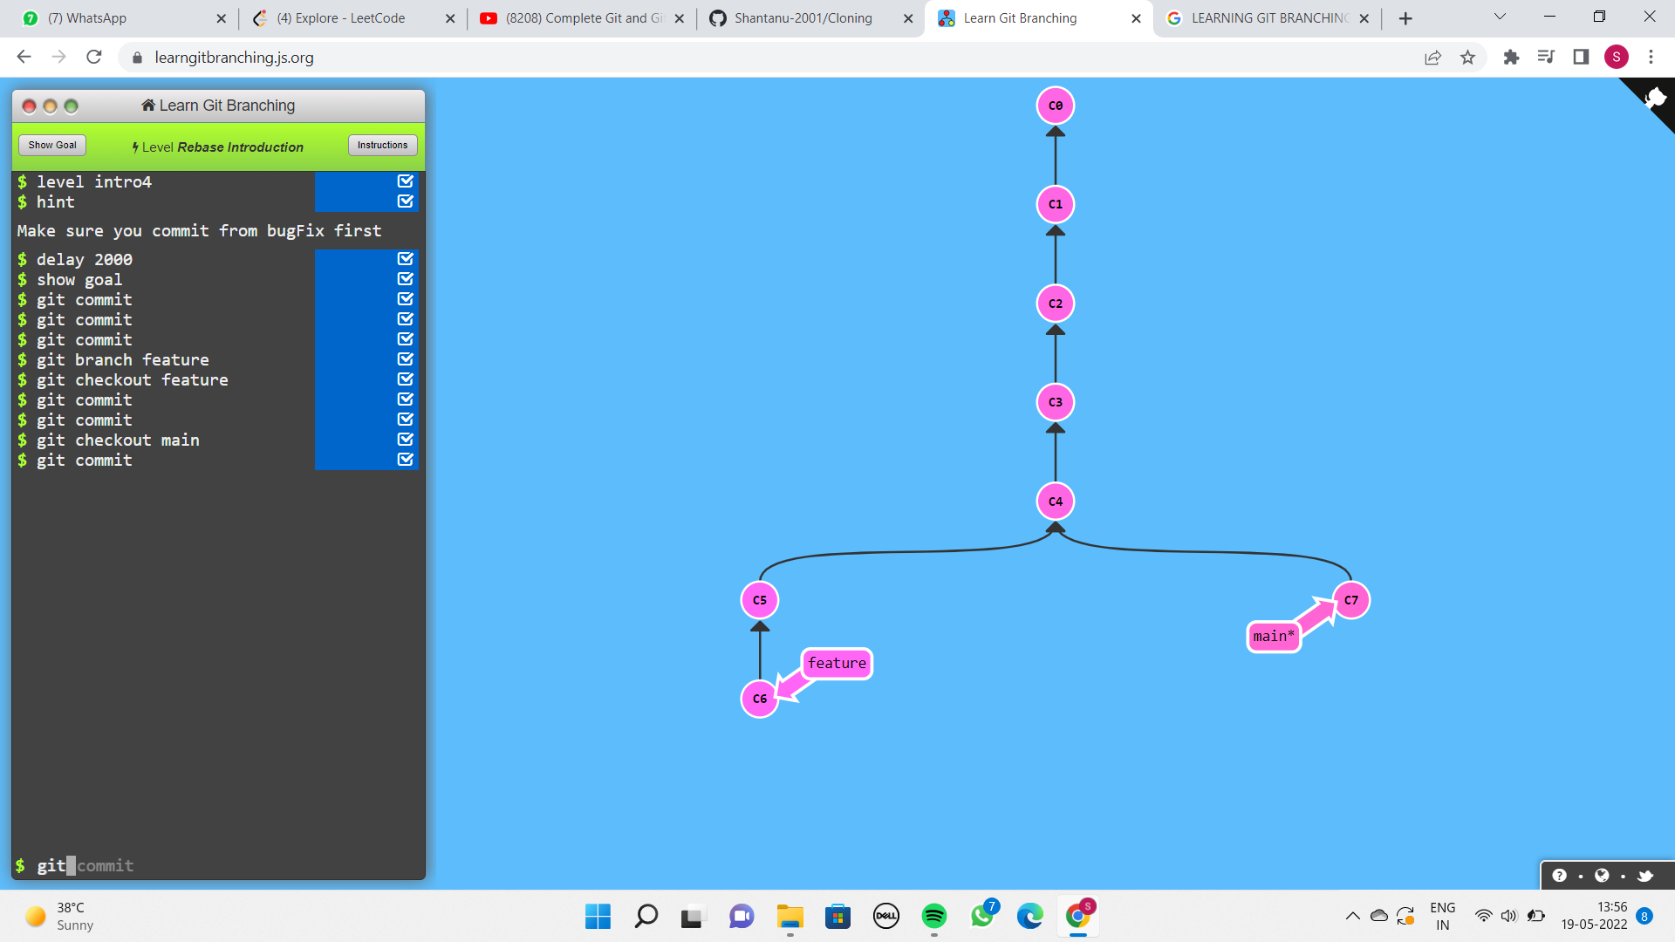

So now the main branch is going to be like this and your work is going on side by side. So this is the use of branches.

So currently my head is on main branch. Whenever we make any new commit it will be on the main branch.

Now let’s say your features that you are adding in your branch in your code sample that are not currently part of the main branch means users cannot see it. Let’s say the changes are now finalized.

We can merge it by using git merge command :-

**git merge feature**

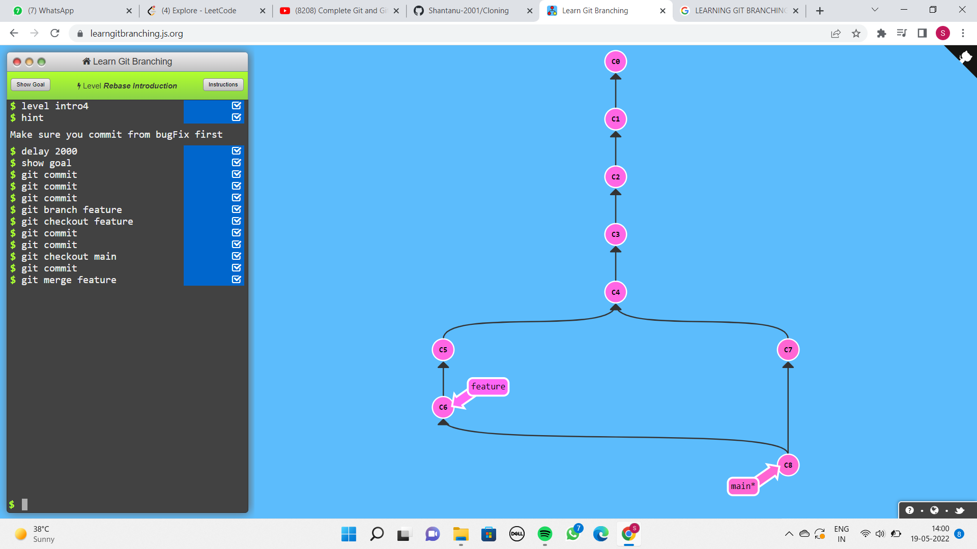

**WORKING WITH EXISTING PROJECTS ON GITHUB**

Example :- So let’s say there is organisation commclassroom and CommclassroomOP is the project of that organisation.

Now what do we need to do in order to make changes to the project and make some contributions to this project.

Should anyone who does not have access to it directly allowed to make changes to commclassroom project. This would be so dangerous.

We can’t directly change any file in this folder because we don’t have access to this account.

So what is the way to contribute to this code sample without permissions ?

So I’ll create the copy of this project in my own account.

**STEP 1 :- Click on fork.**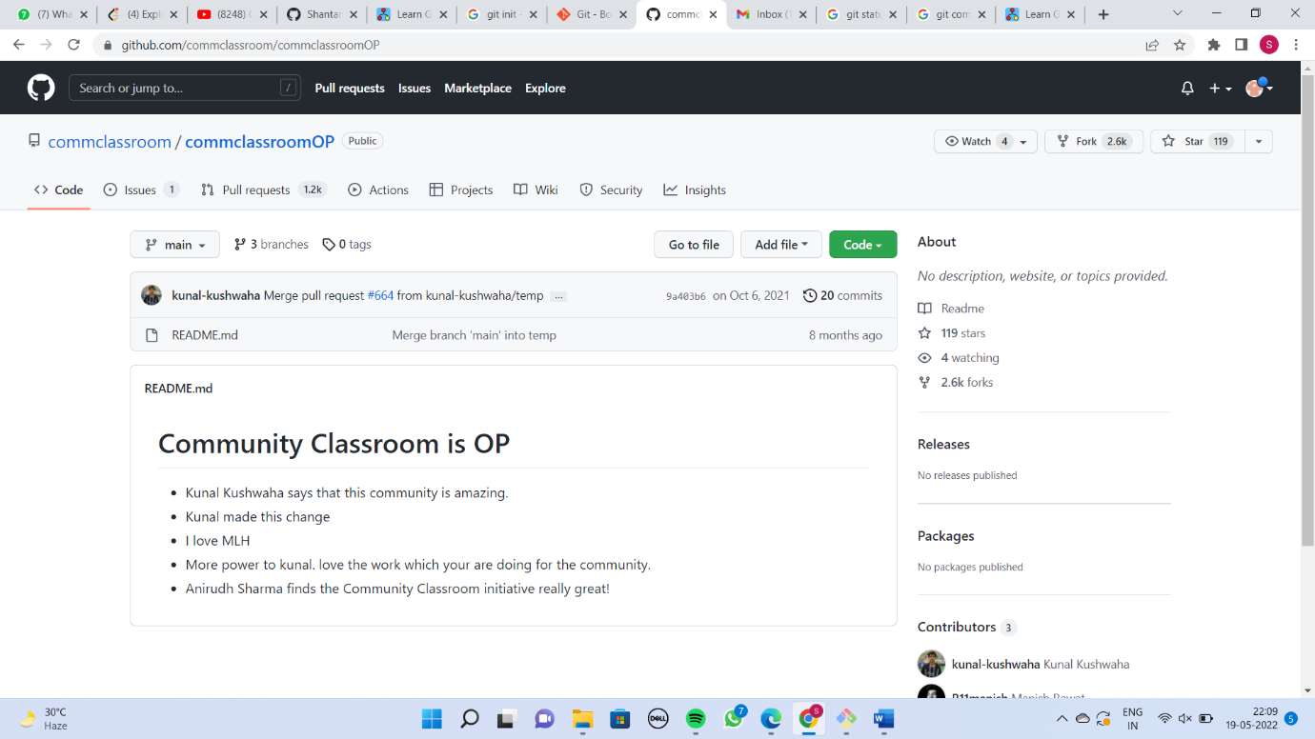



**STEP 2:- Create fork**.

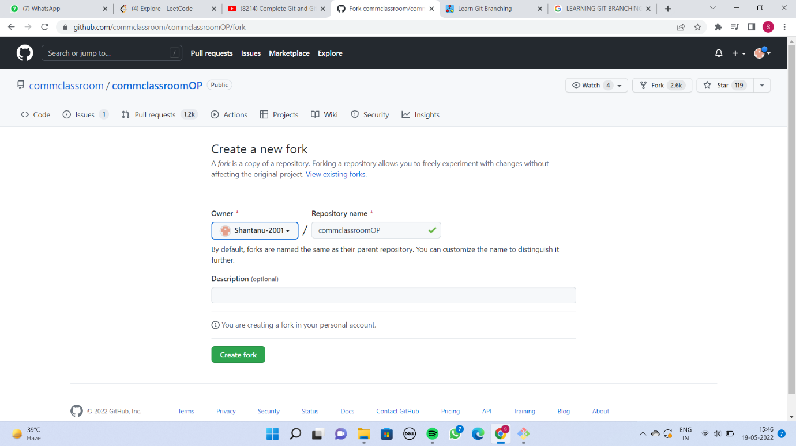

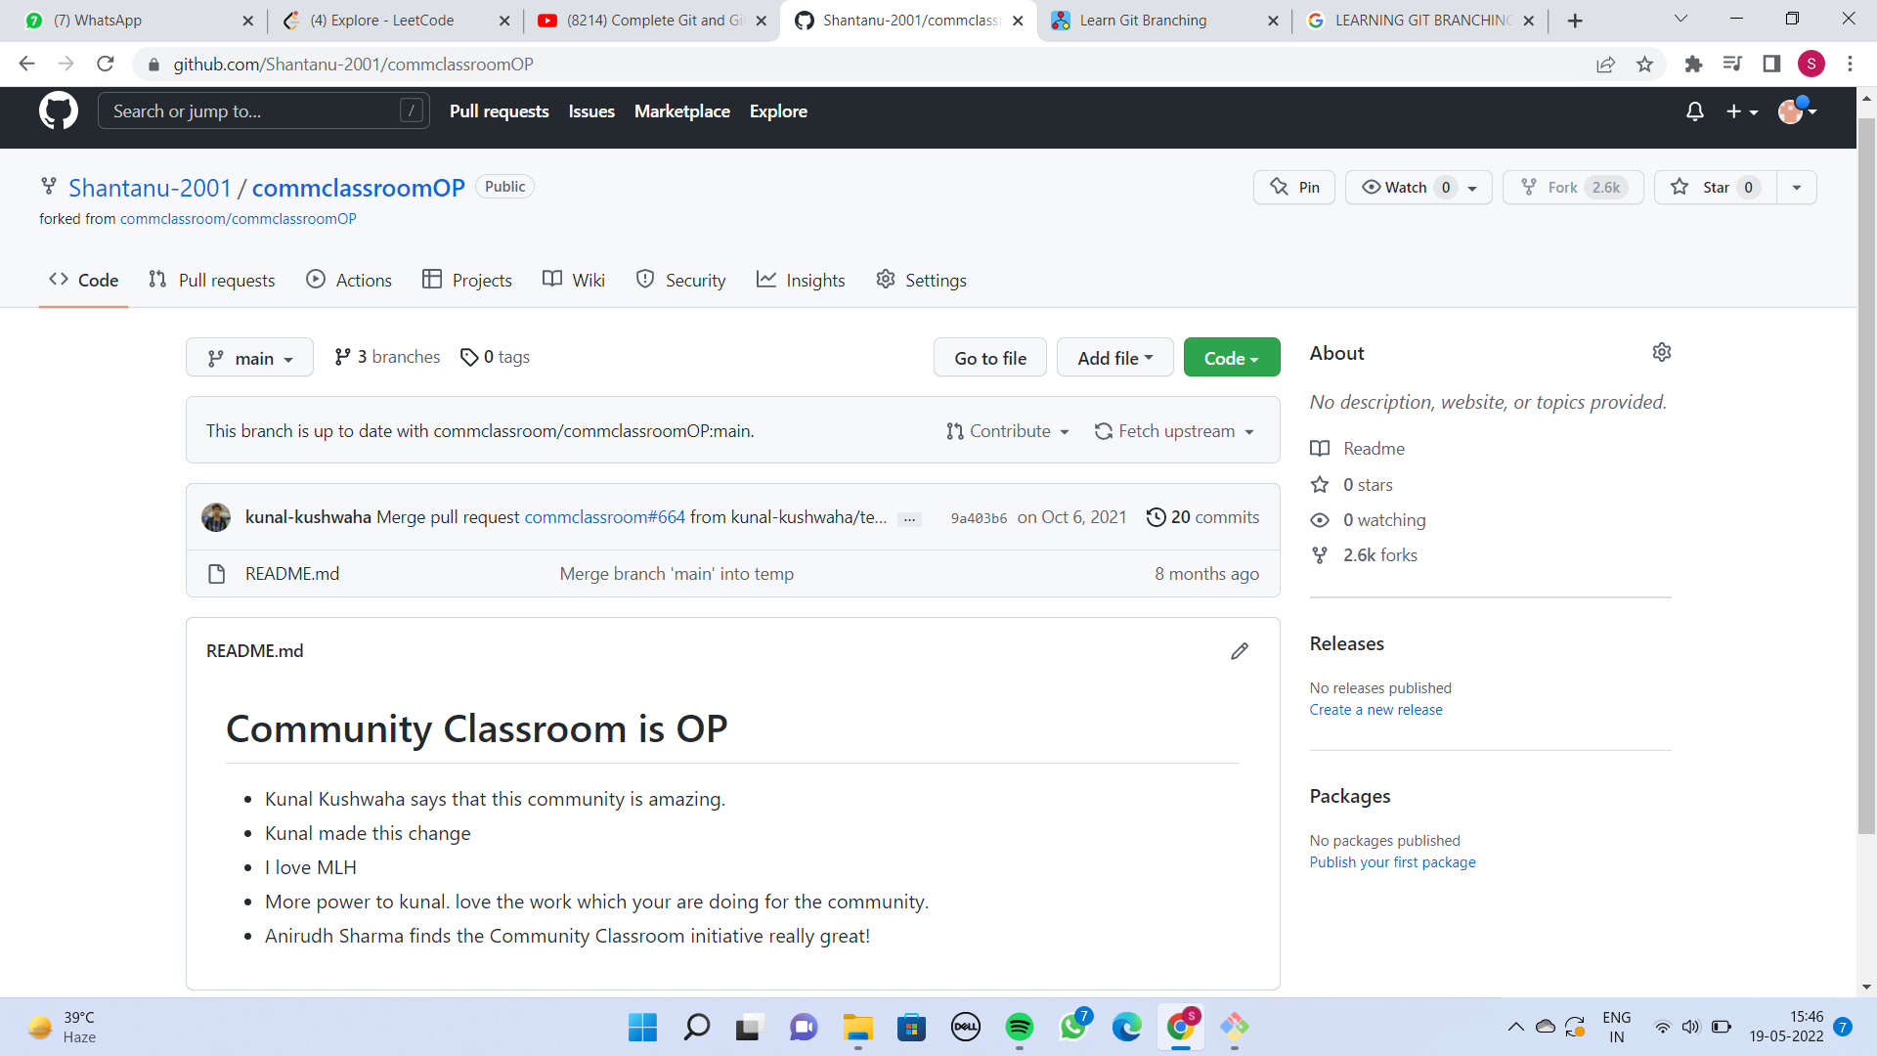



So now you can see instead of CommclassroomOP project it is now **Shantanu-2001 / CommclassroomOP** project.

So now this CommclassroomOP is in my account so I can do anything with it.

**CLONING THE FORKED PROJECT TO LOCAL**

Since the commclassroomOP is in our own account so we can do anything we want to do with it.

Click on code and copy the URL

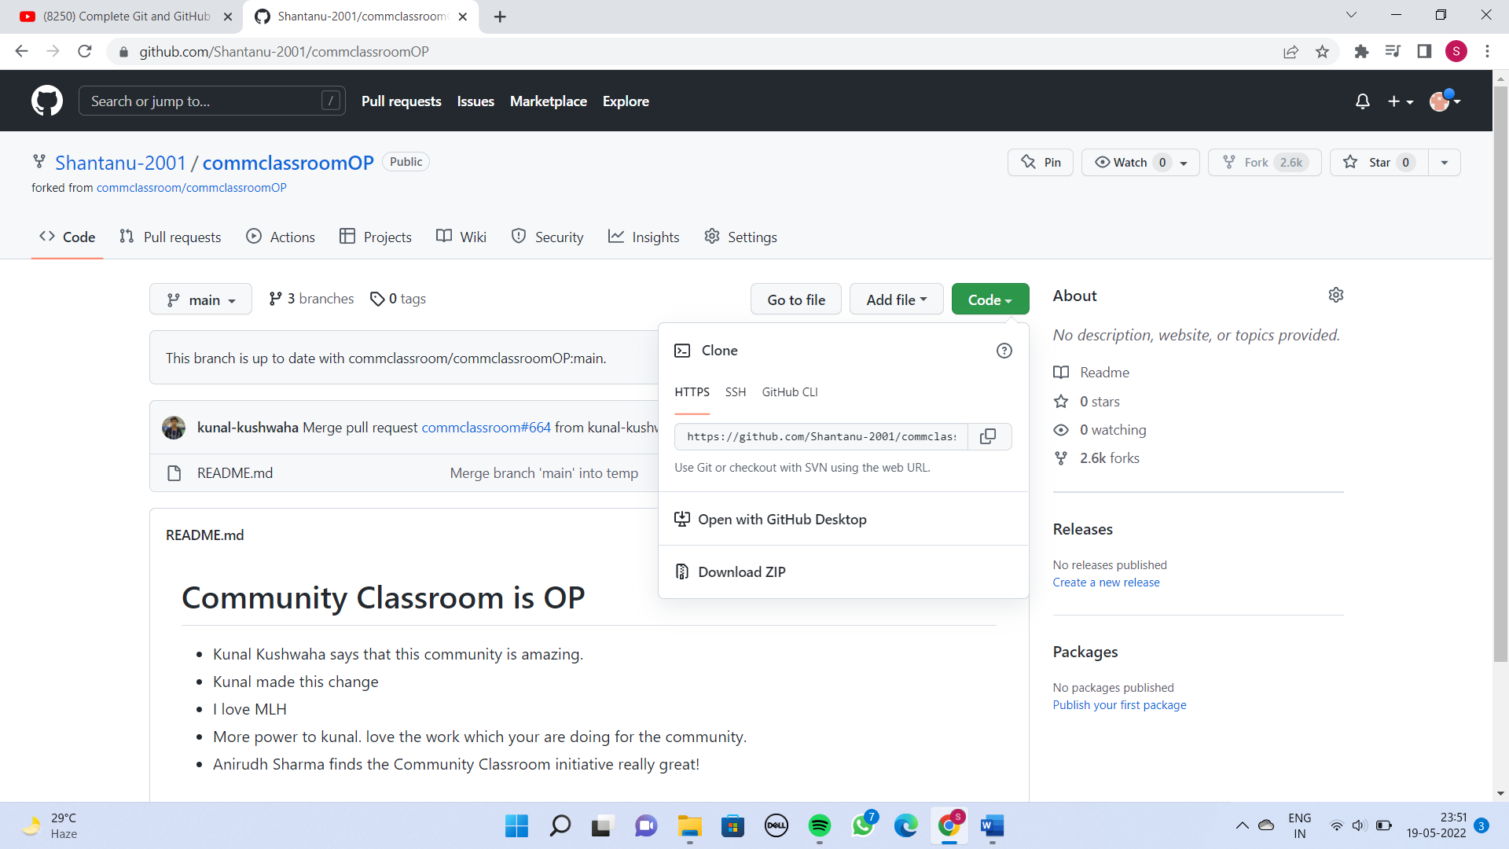

In terminal type the command :-

git clone URL

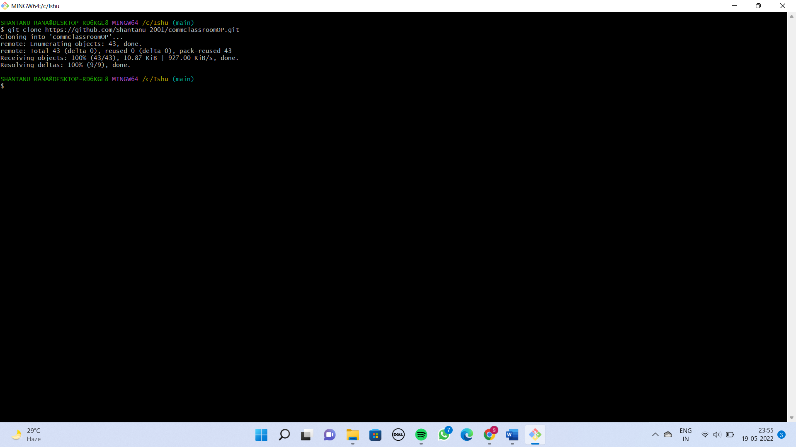

So now I have commclassroomOP in my local repository.

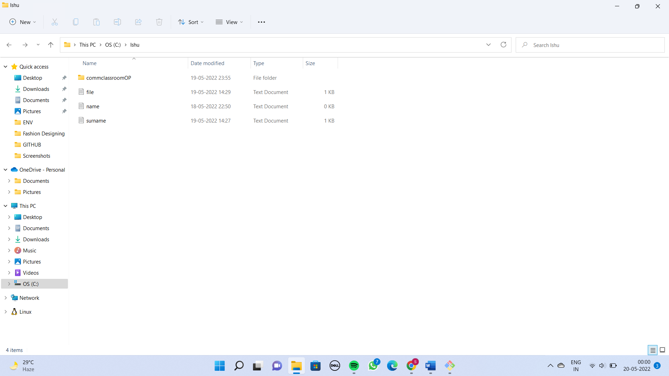

**WHAT IS UPSTREAM AND ADDING TO LOCAL**

You know that the origin URL is basically your own account.

From where we have forked this project that is known as upstream URL by convention.

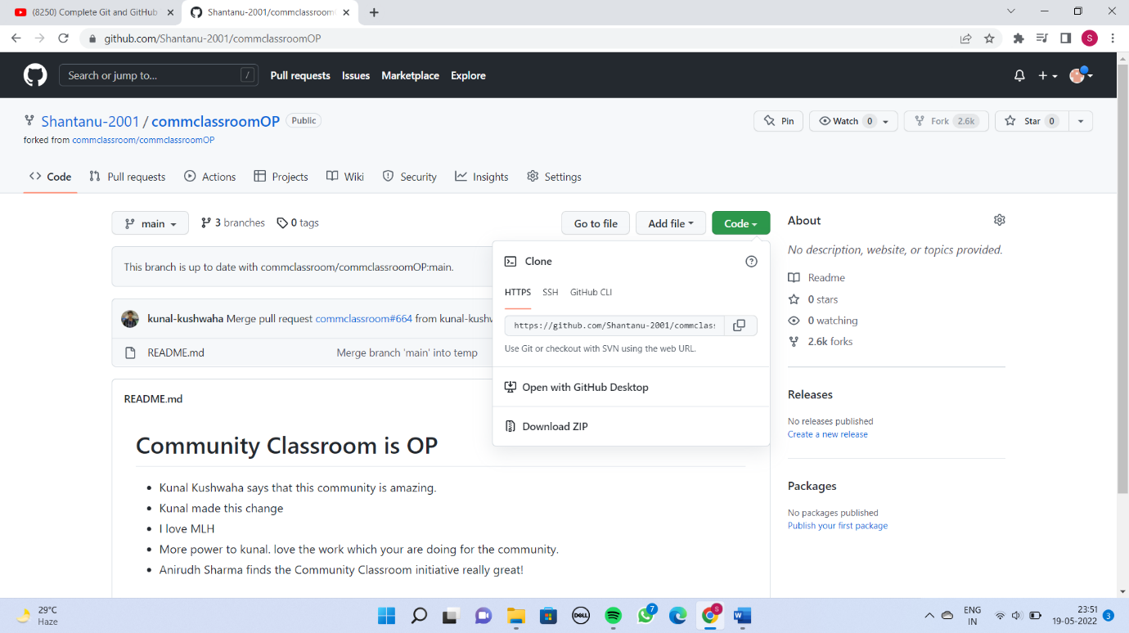



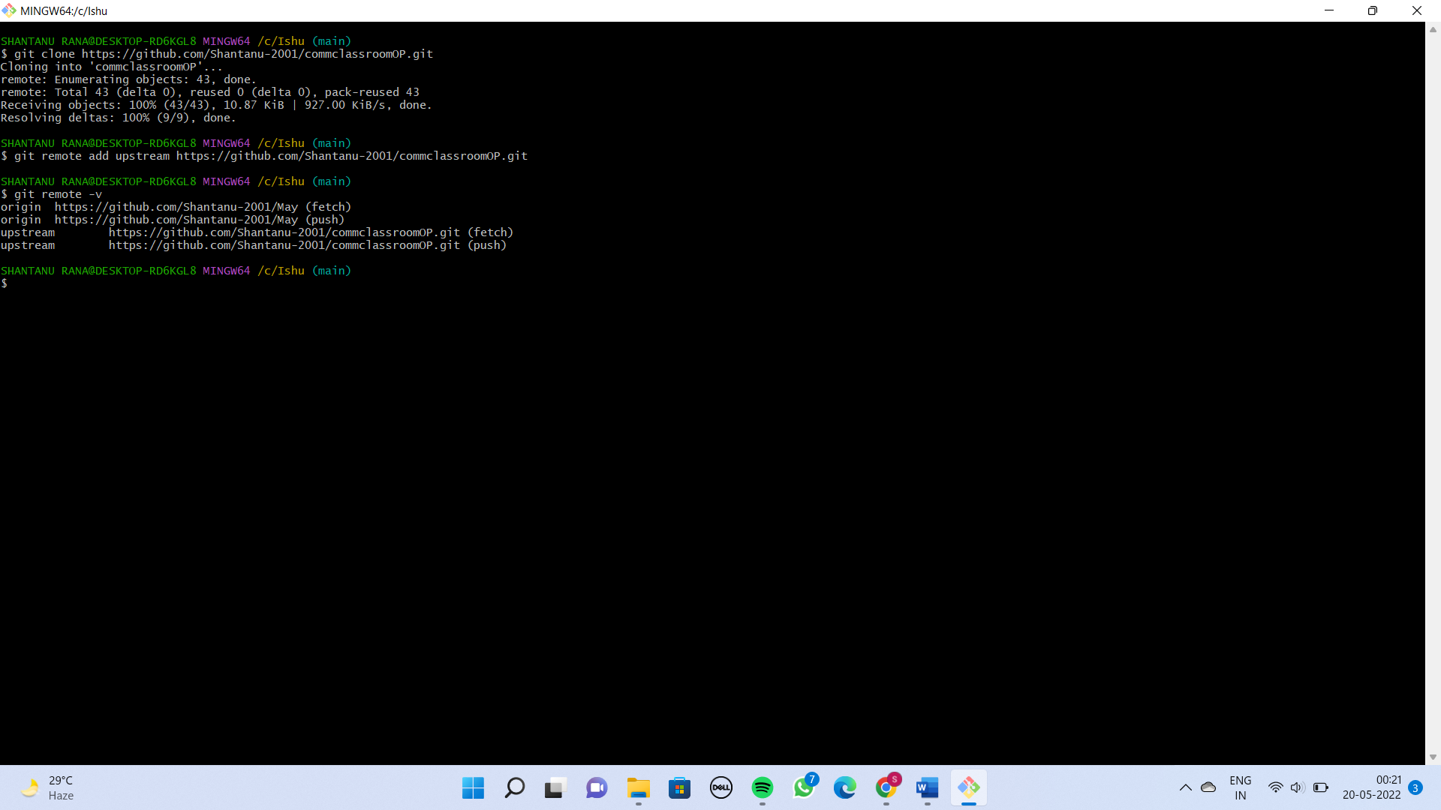

Origin is my personal and upstream is where I have forked it.

**WHAT IS A PULL REQUEST**

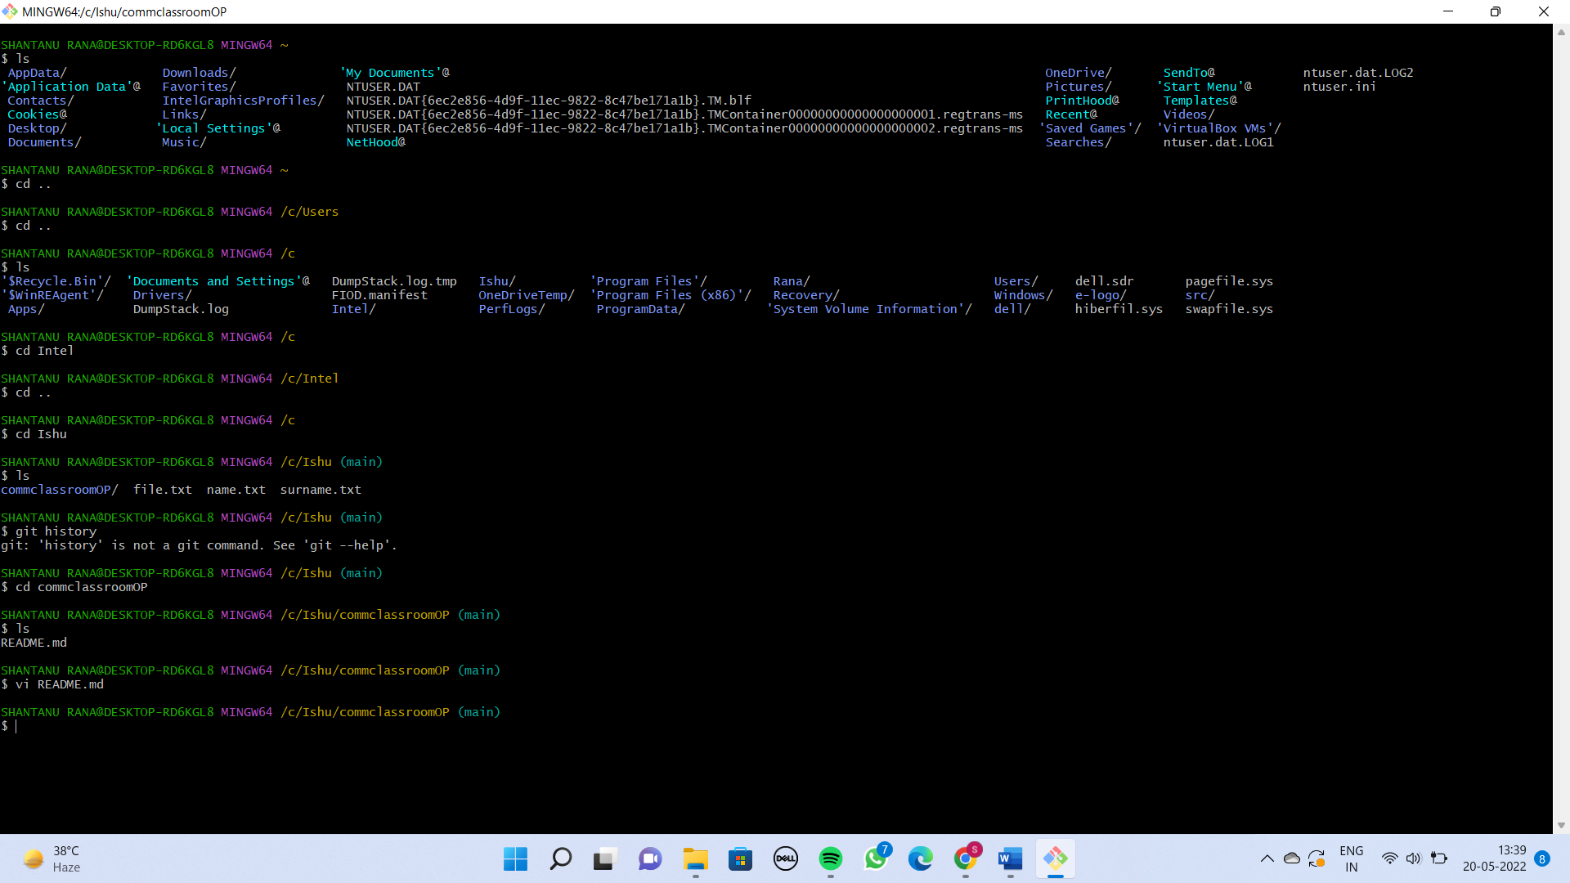

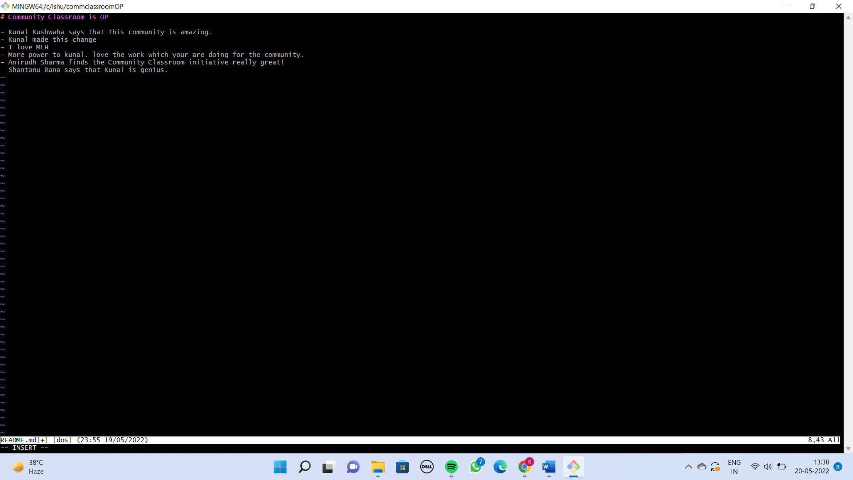

In the beginning we have discussed that never commit in main branch. Always create a new branch for what ever work you are doing.

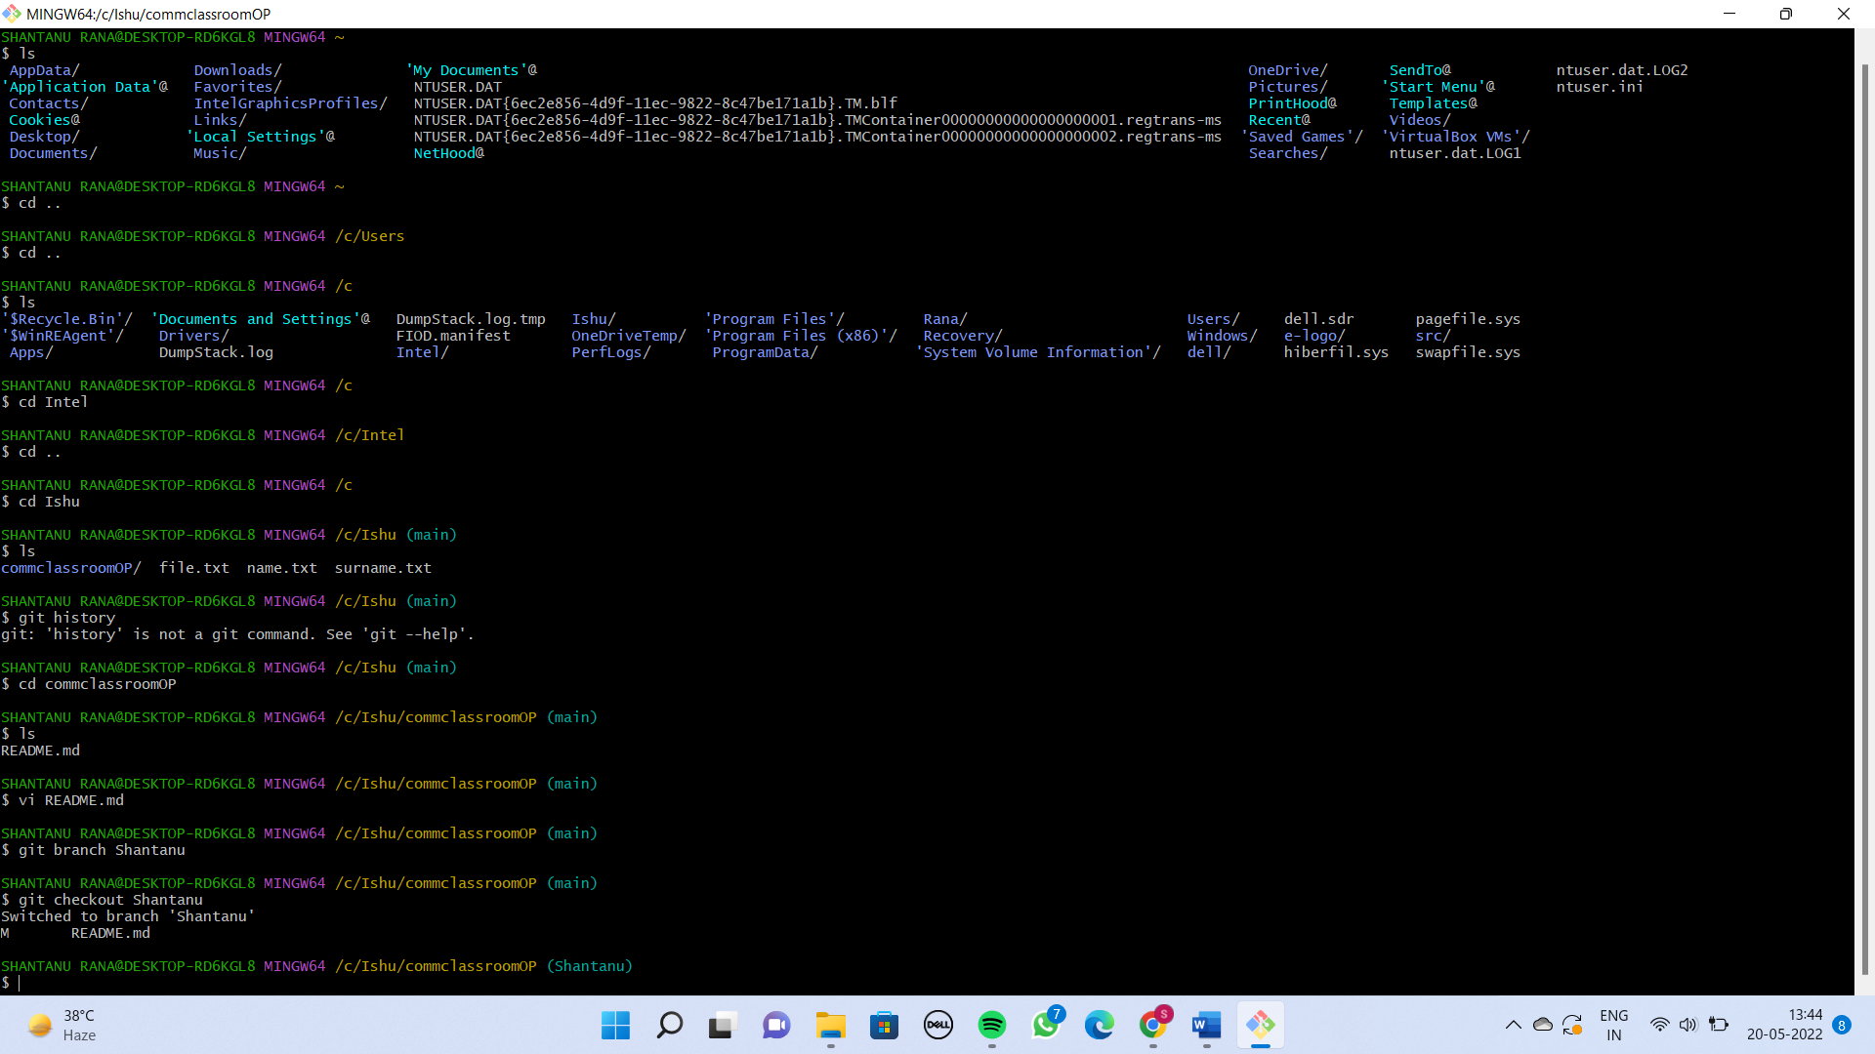

All the commits I’ll make will go to the Shantanu Branch.

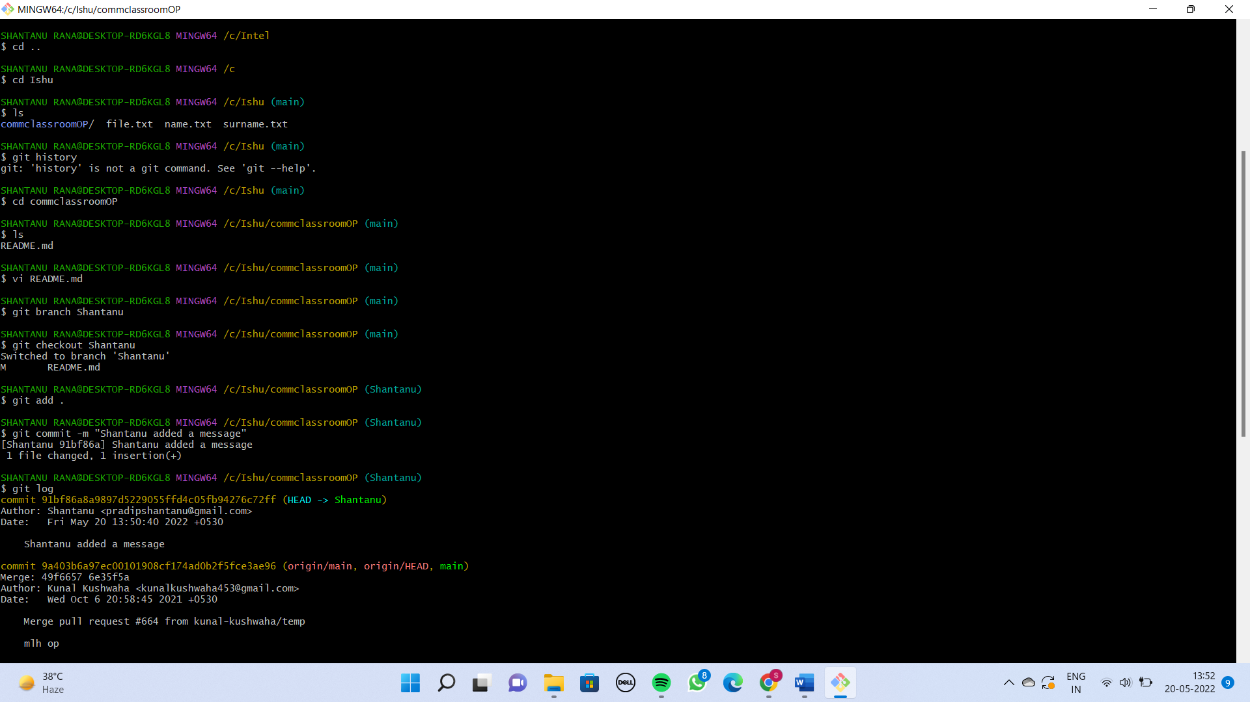

Now basically I want to push this branch. Whatever code which I have in Shantanu branch of my own account please merge that into the main project’s main branch.

So I’ll do a Pull request to people in which project I want to merge my Shantanu branch.

Now push this branch on Github.

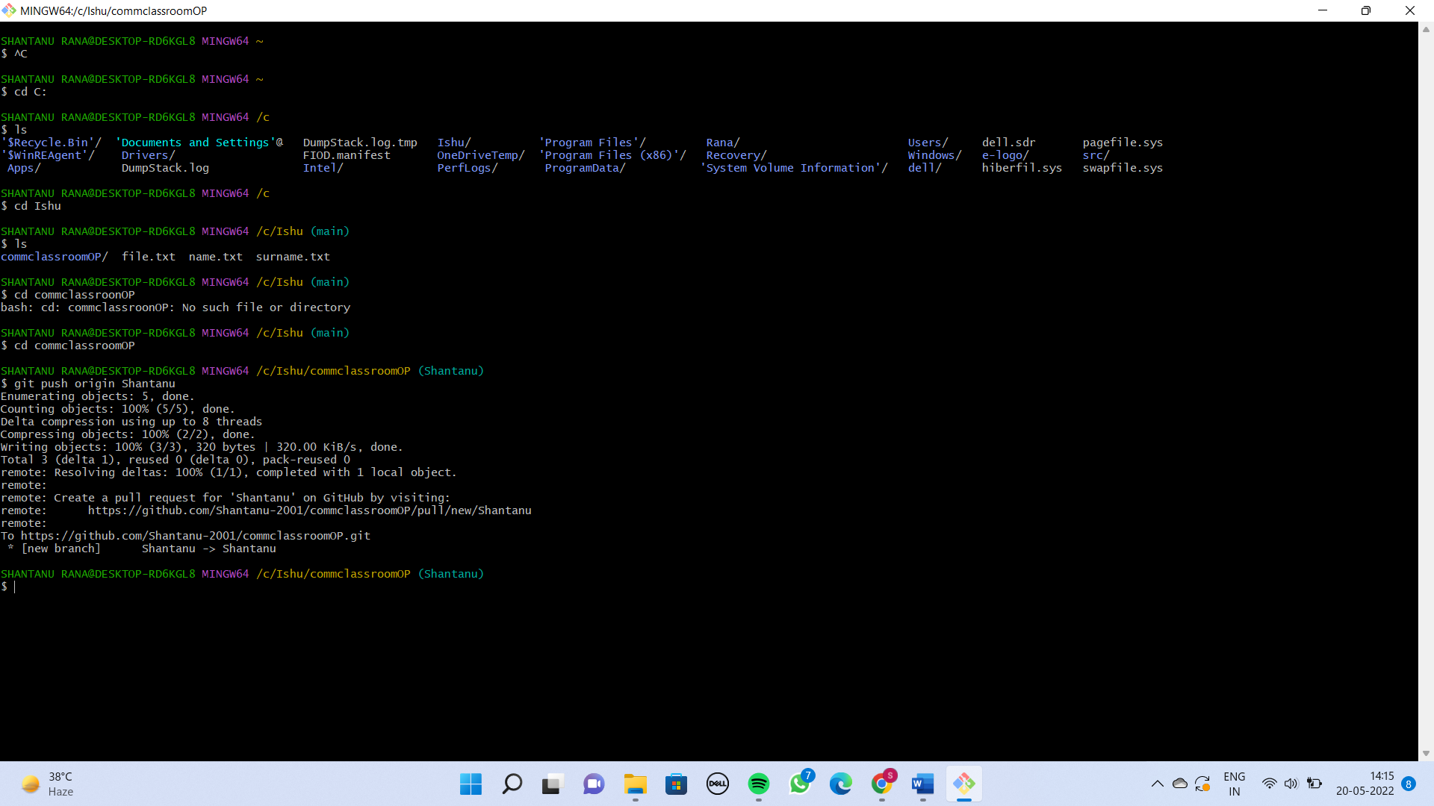

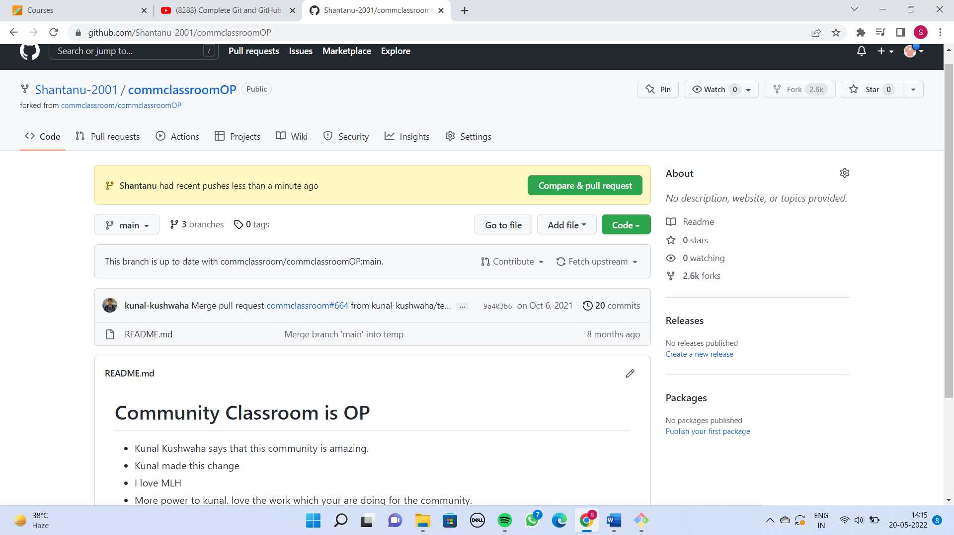



Now Automatically this will come on the repository.

Click on compare& pull request.

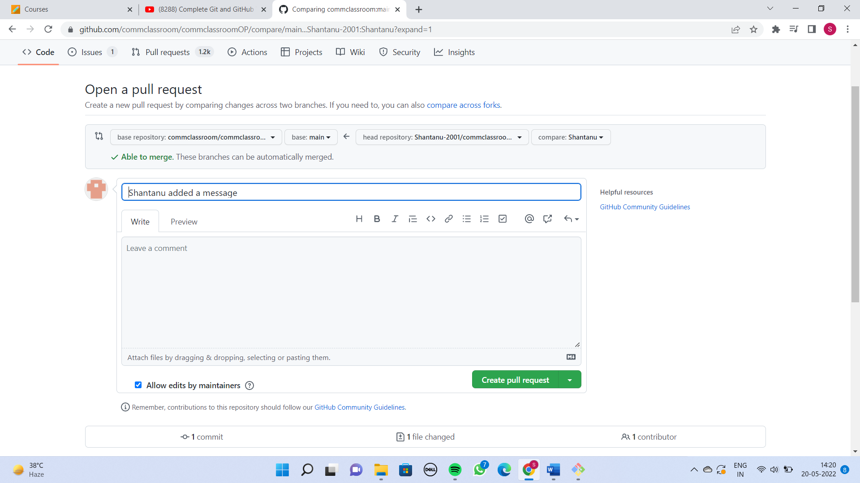



Click on create pull request.

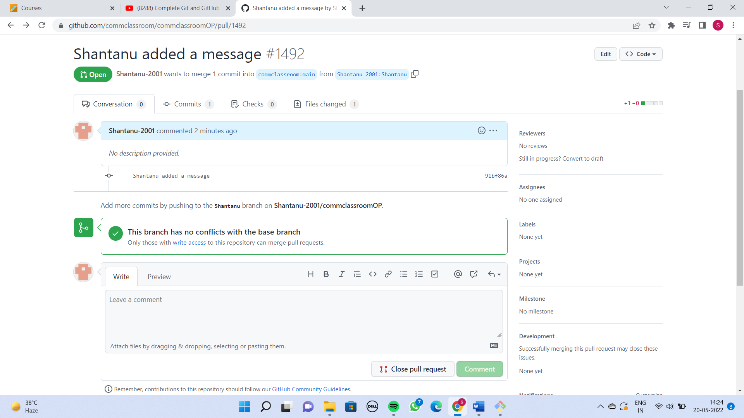

After that I can merge my branch into main branch.

**SQUASHING THE COMMITS**

The concept says that If you have lots of commits that you are working on and you want to merge that into one commit.

I have created 4 files with 4 commits.

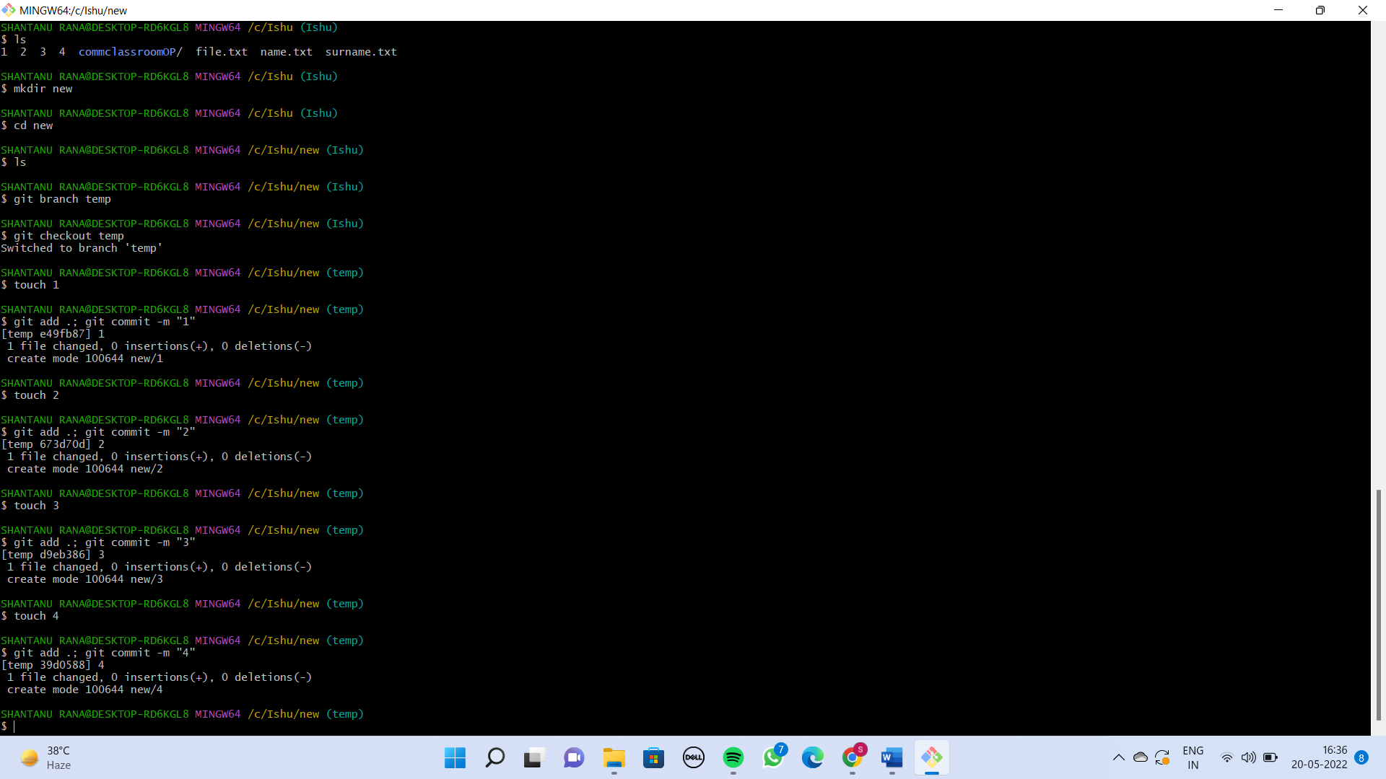

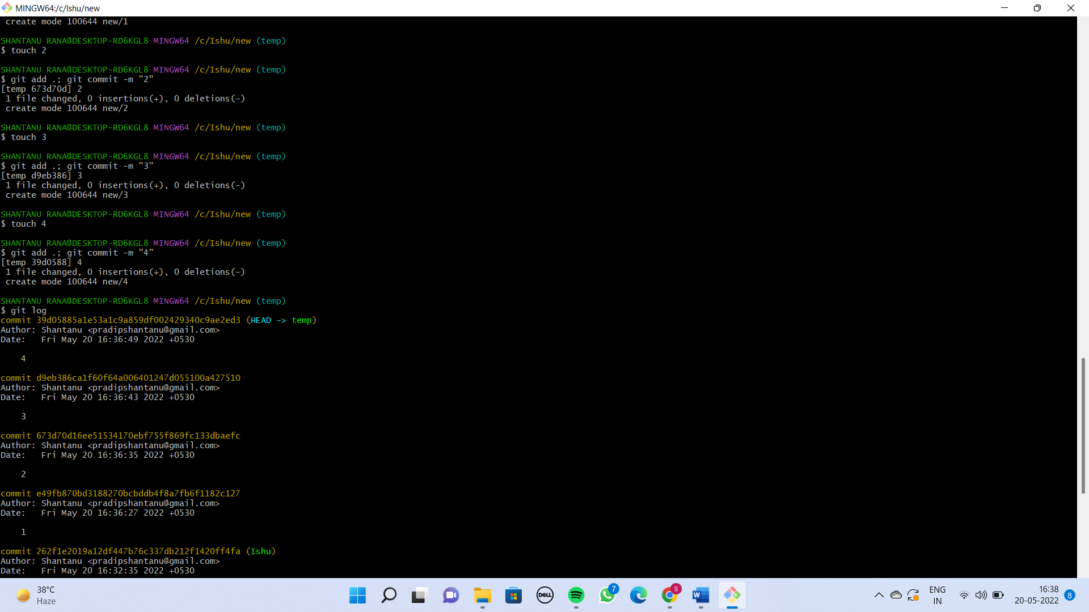

Now I want to merge all these 4 commits into 1 single commit.

I’ll use the rebase command for that.

git rebase -i e49fb870bd3188270bcbddb4f8a7fb6f1182c127

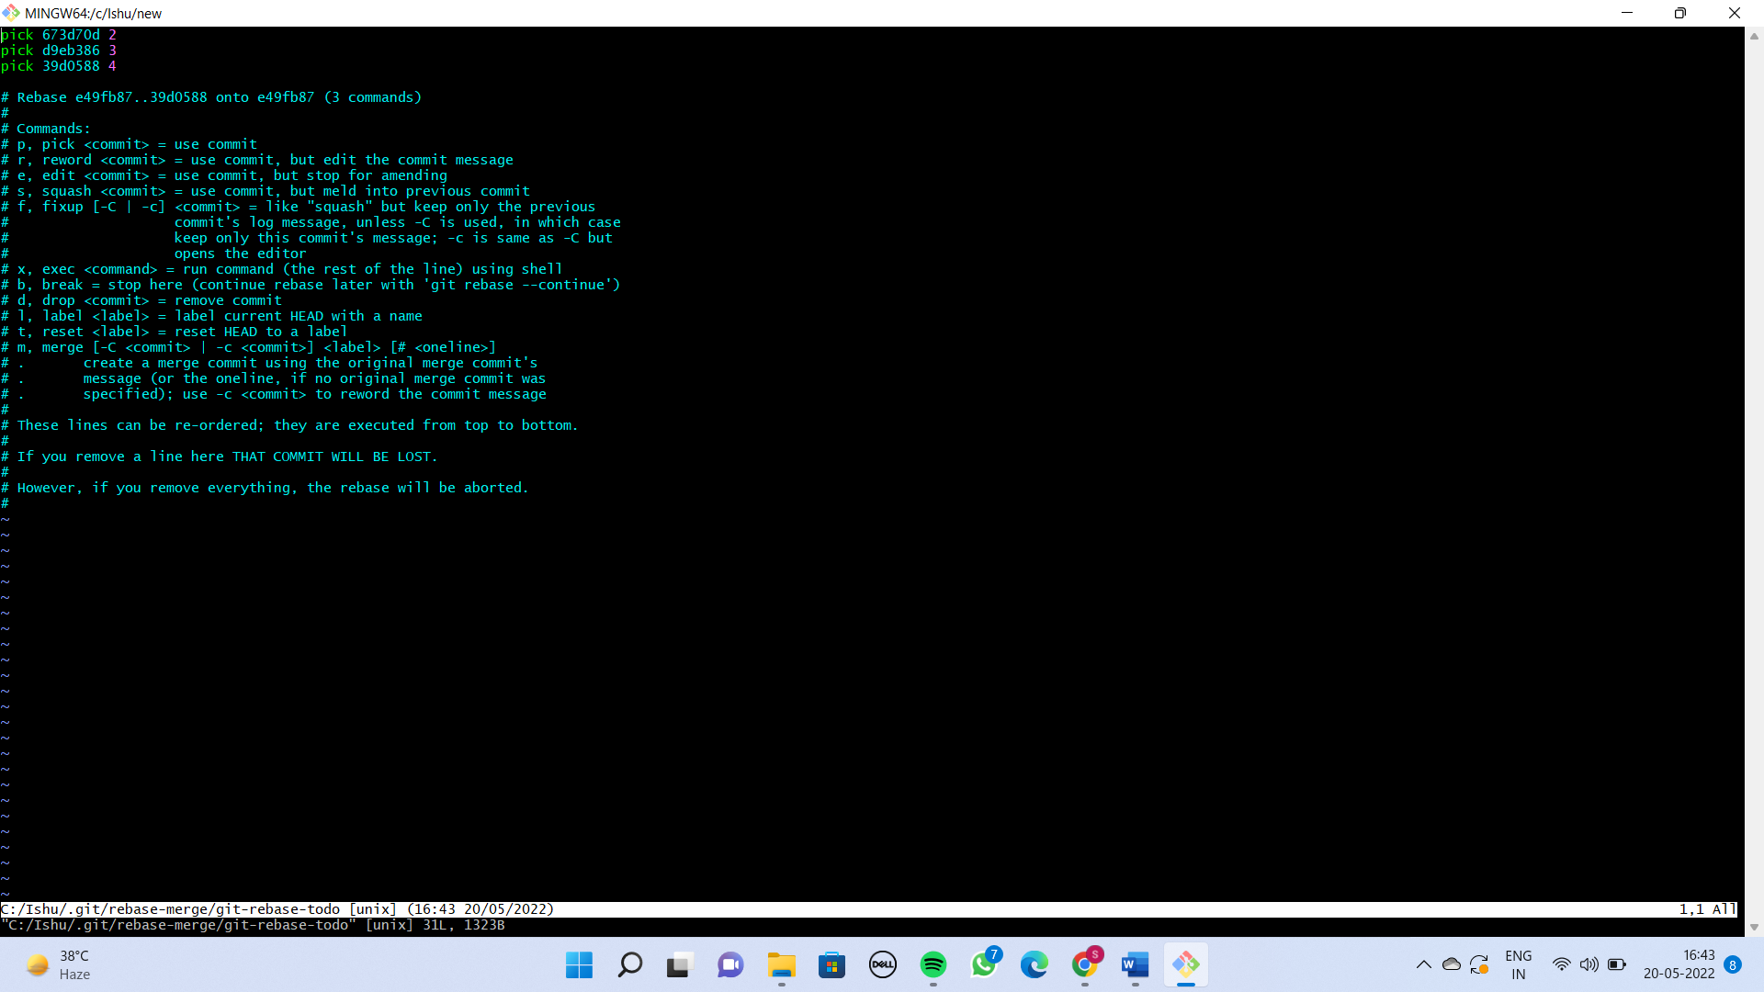



So I can see all the commits above it. I can either pick or squash.

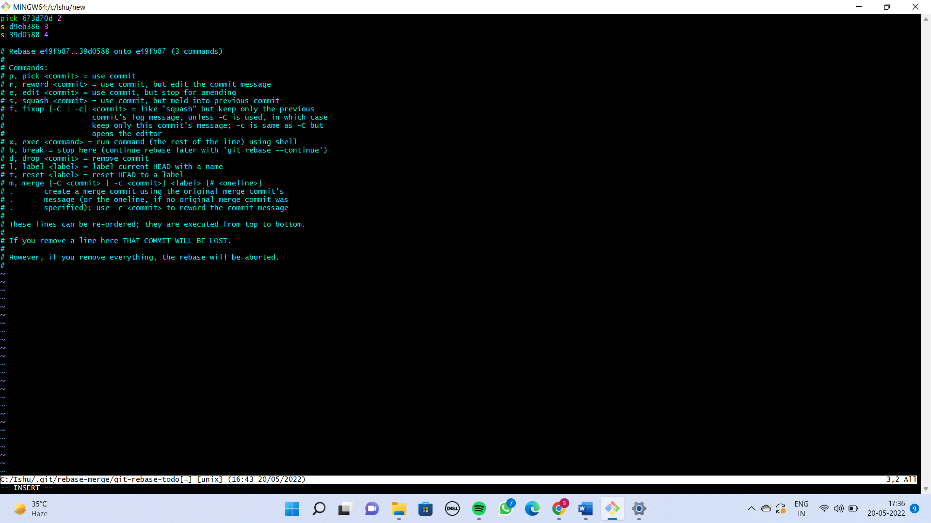

Here I’m merging my 3rd  and 4th commit into 2nd commit.

After that do :-

**Press esc key then :x then press enter.**

After that I will type new message here which is **“commits merged”.**

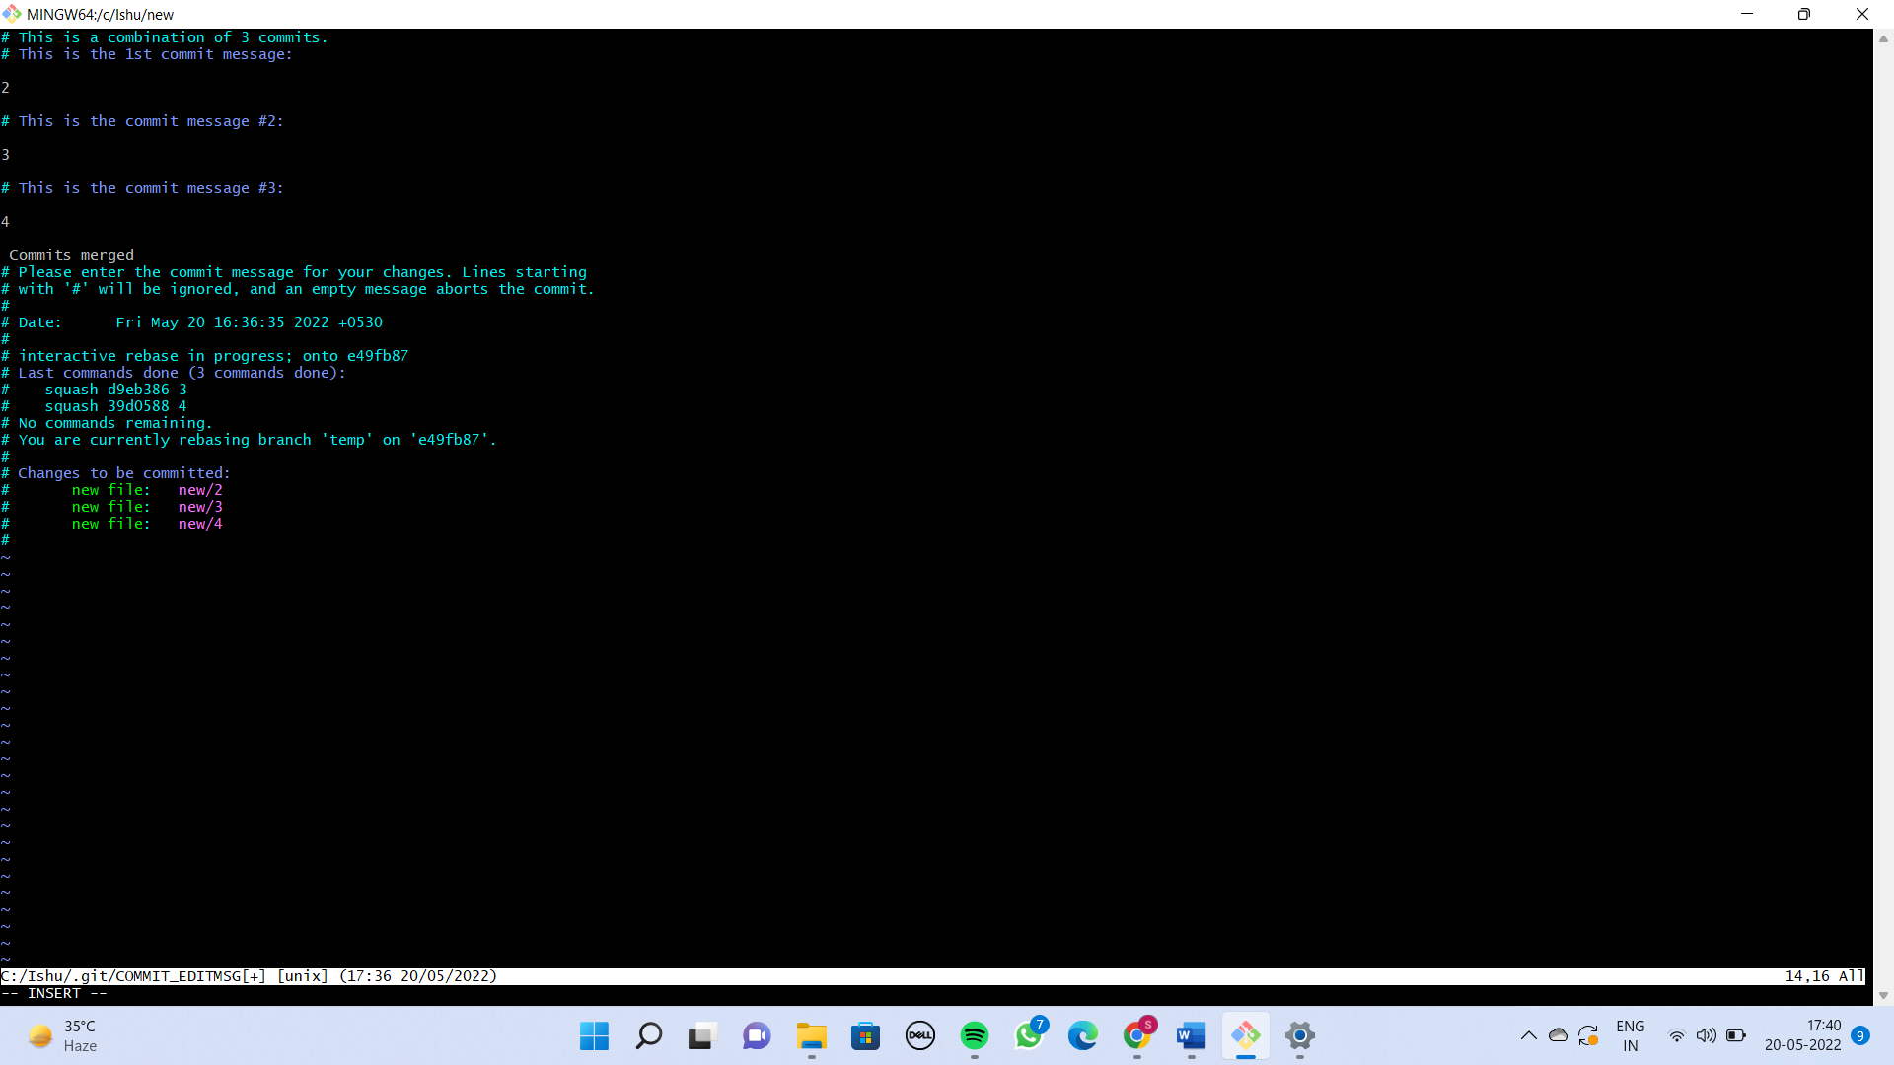



After that again do :-

**Press esc key then :x then press enter.**

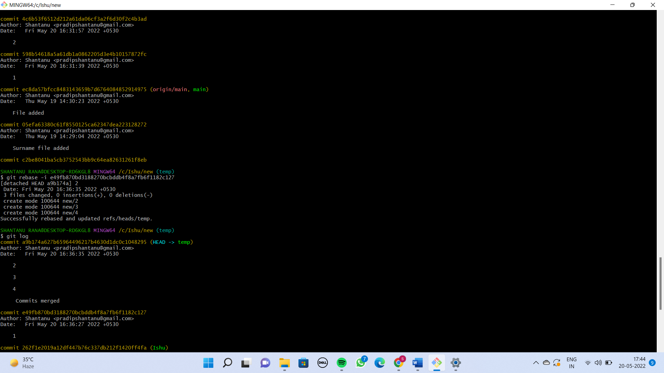

Finally the 3rd and 4th commits are merged into 2nd commit.